**Assignment No:-21**

Name:-Suryawanshi Sangramsingh Sambhaji

Batch: - Delta - DCA (Java) 2024 Date:-3/6/2024

**\*First day Question.**

**Q1.** **Write a program to input an array and print it.**

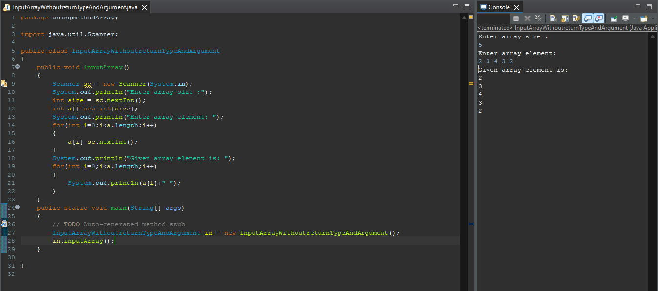

**Q2.** **Write a program initialise an array and print it.**

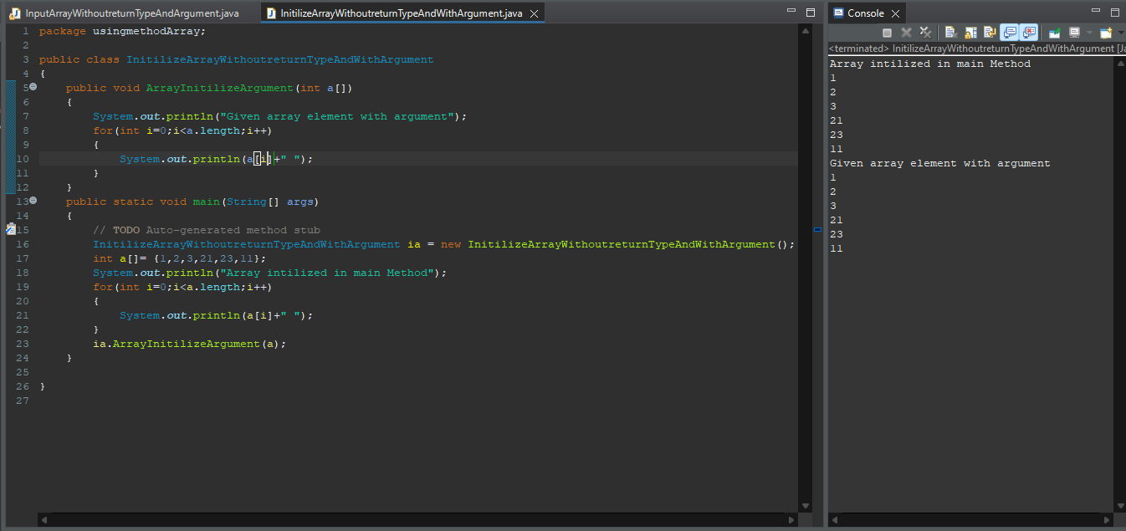

**Q3.** **Write a program to input an array and print its 1st and last element.**

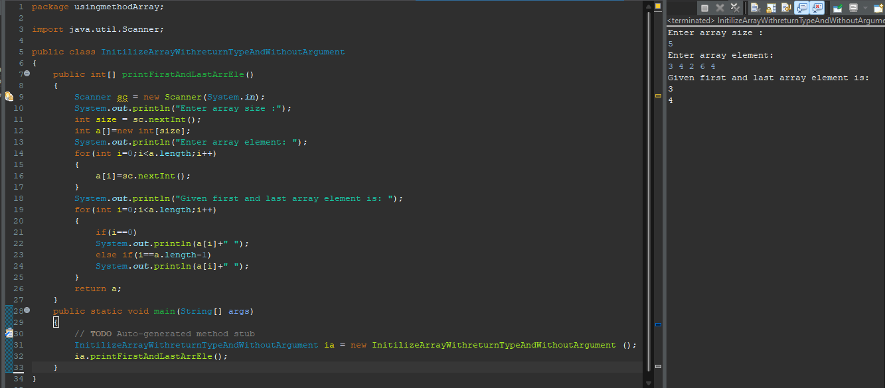

**Q4.** **Write a program to input an array and find sum of its 1st and 2nd element.**

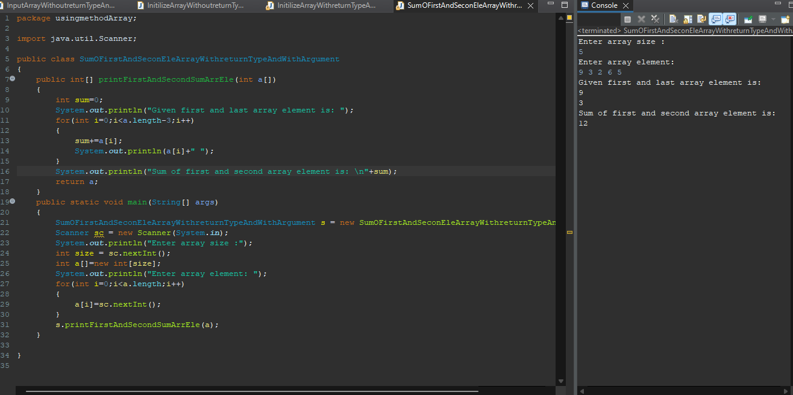

**Q5.** **Write a program to input an array and find sum.**

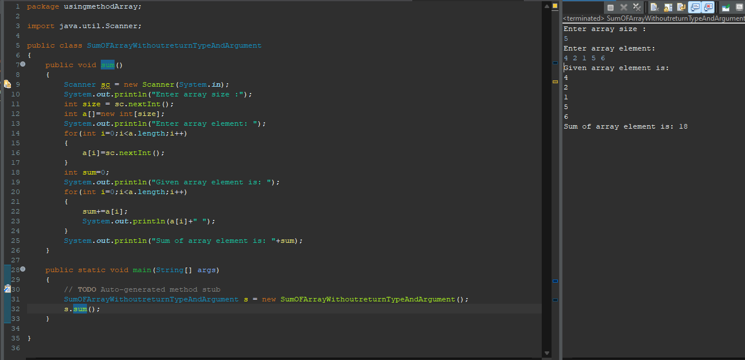

**Q6.** **Write a program to input an array and find its average.**

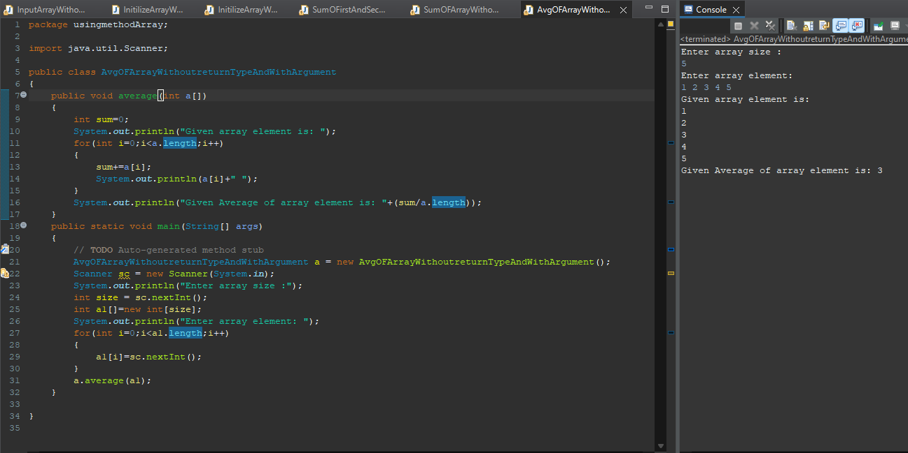

**Q7.** **Write a program to input an array and print even no**

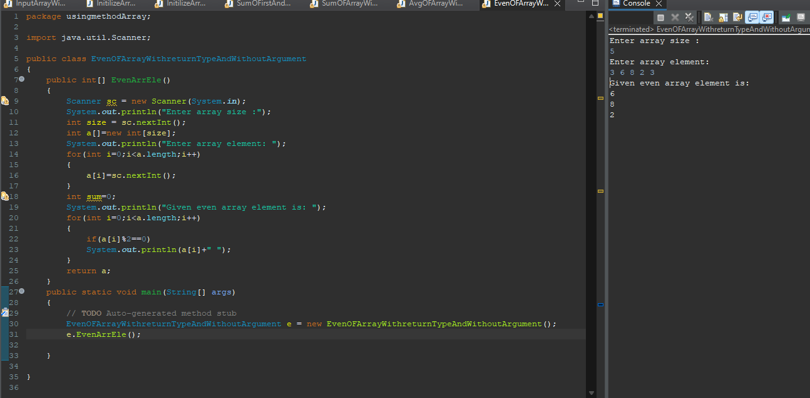

**Q8.** **Write a program to input an array and print odd no.**

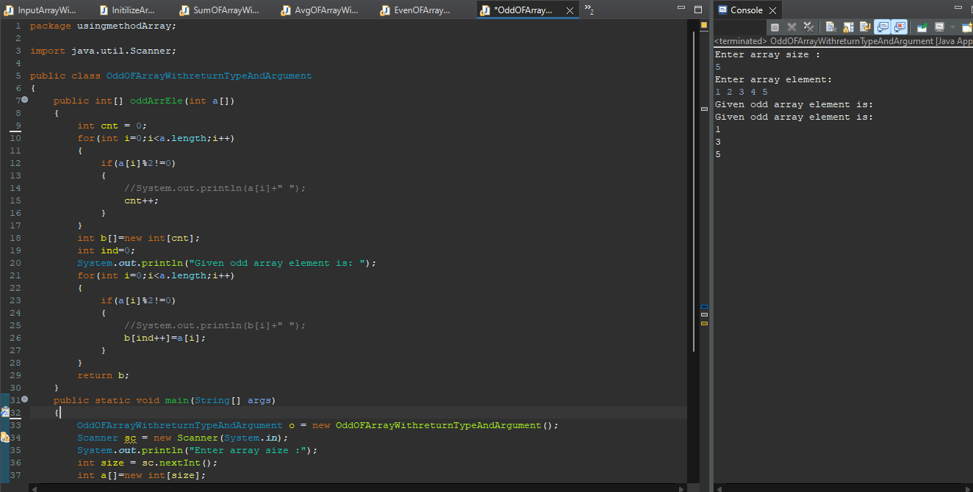 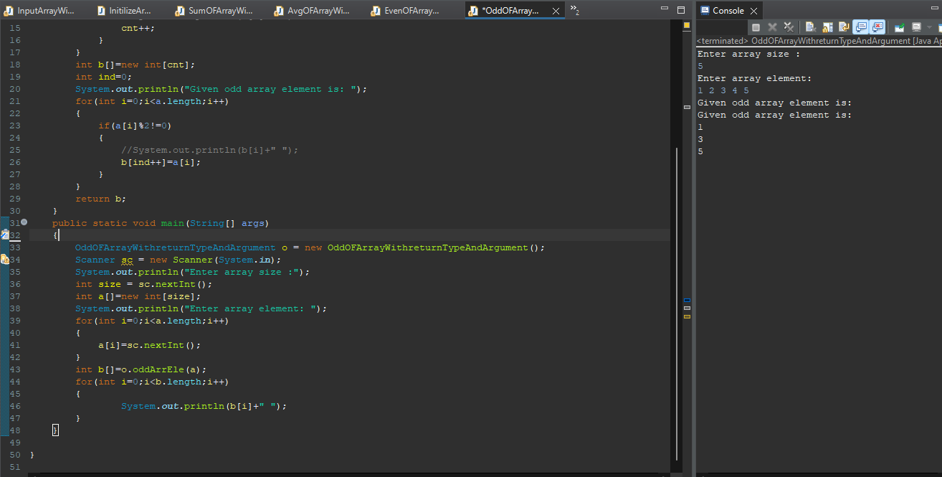

**Q9. Write a program to input an array and find the sum of even no.**

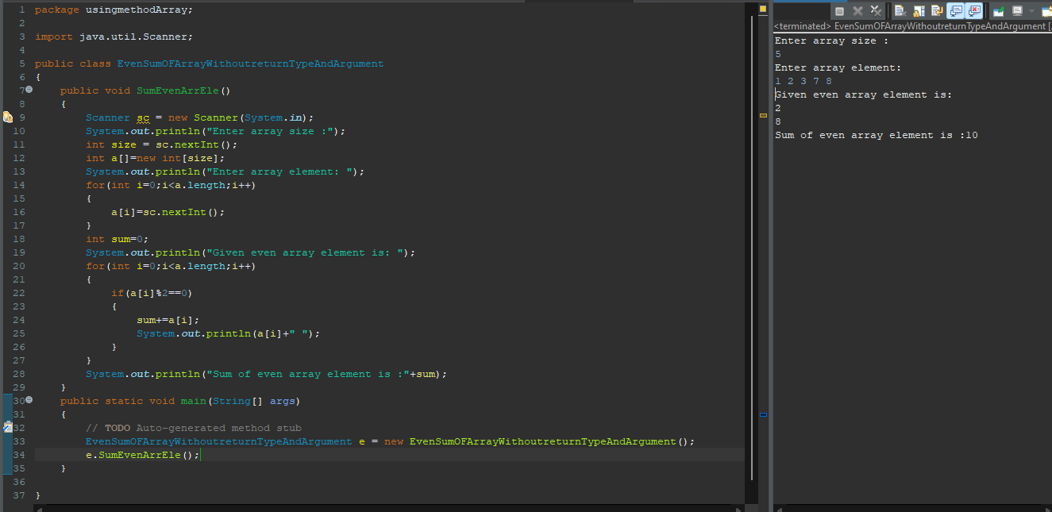

**Q10. Write a program to input an array and find the sum of odd no.**

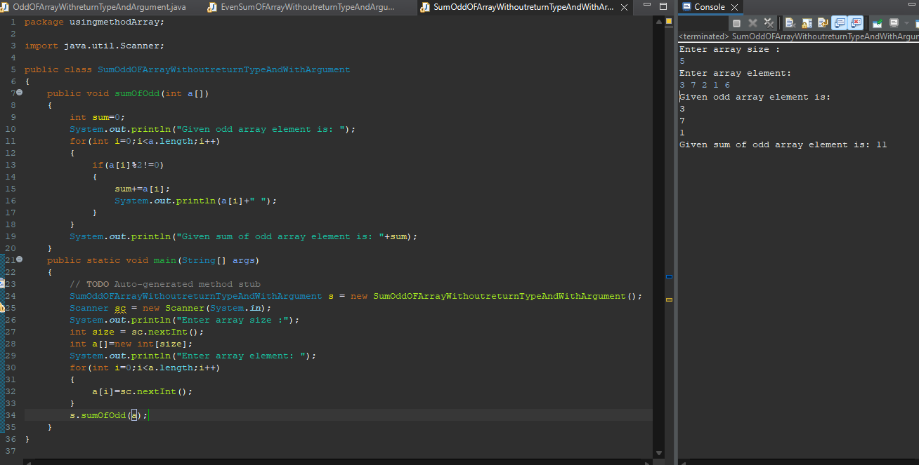

**Q11. Write a program to input an array and print its 1st 2nd and 3rd element.**

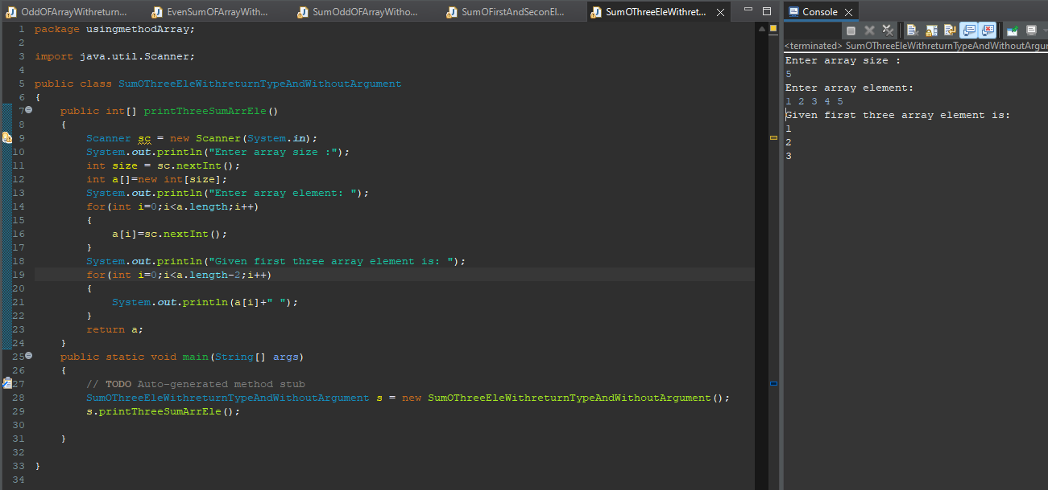

**Q12. Write a program to input an array and find sum of its 1st and 2nd and 3rd element.**

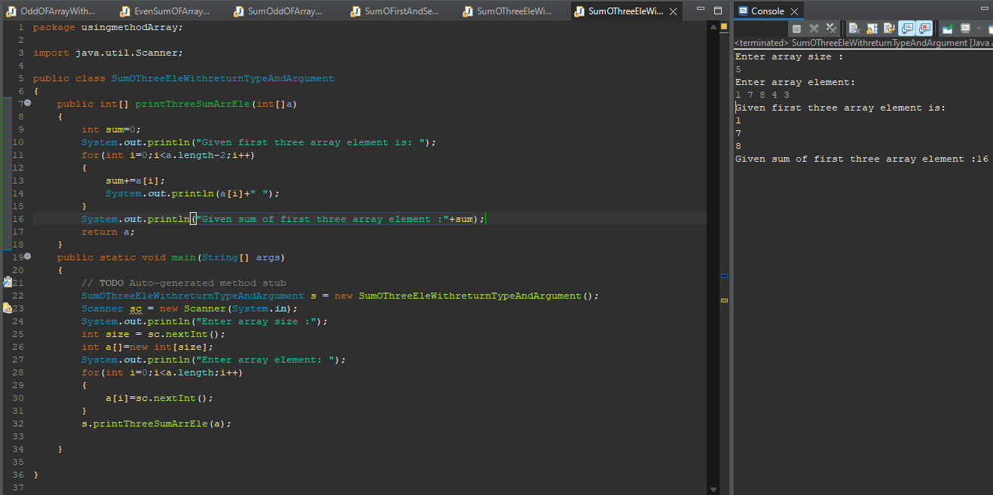

**Q13. Write a program to input an array and find no of 0s.no of positive no.no of negative no.**

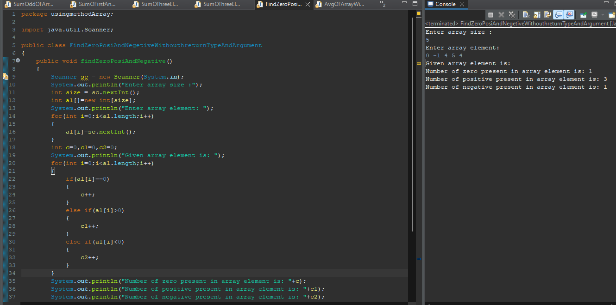 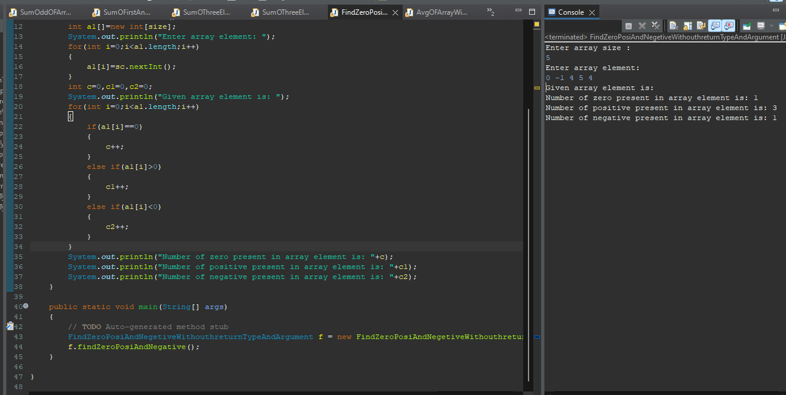

**Q14. Write a program to input an array and find its average of first 5 element.**

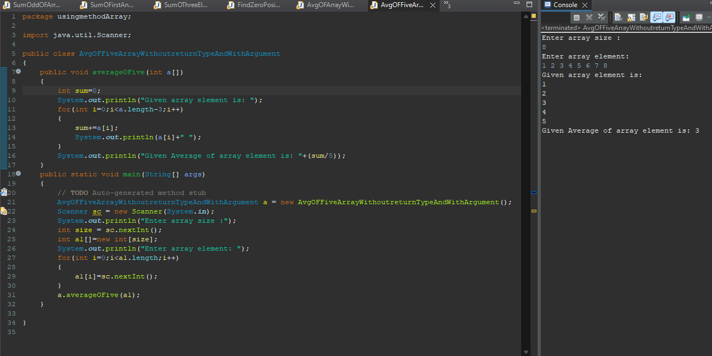

**Q15. Write a program to input an array and print the sum and count of even no.**

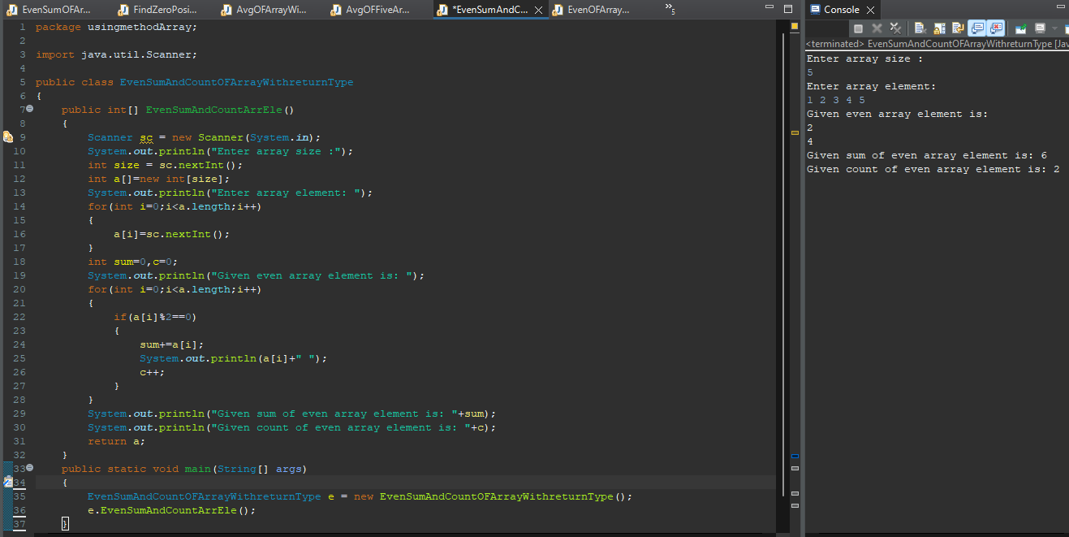

**Q16. Write a program to input an array and print the sum and count of odd no.**

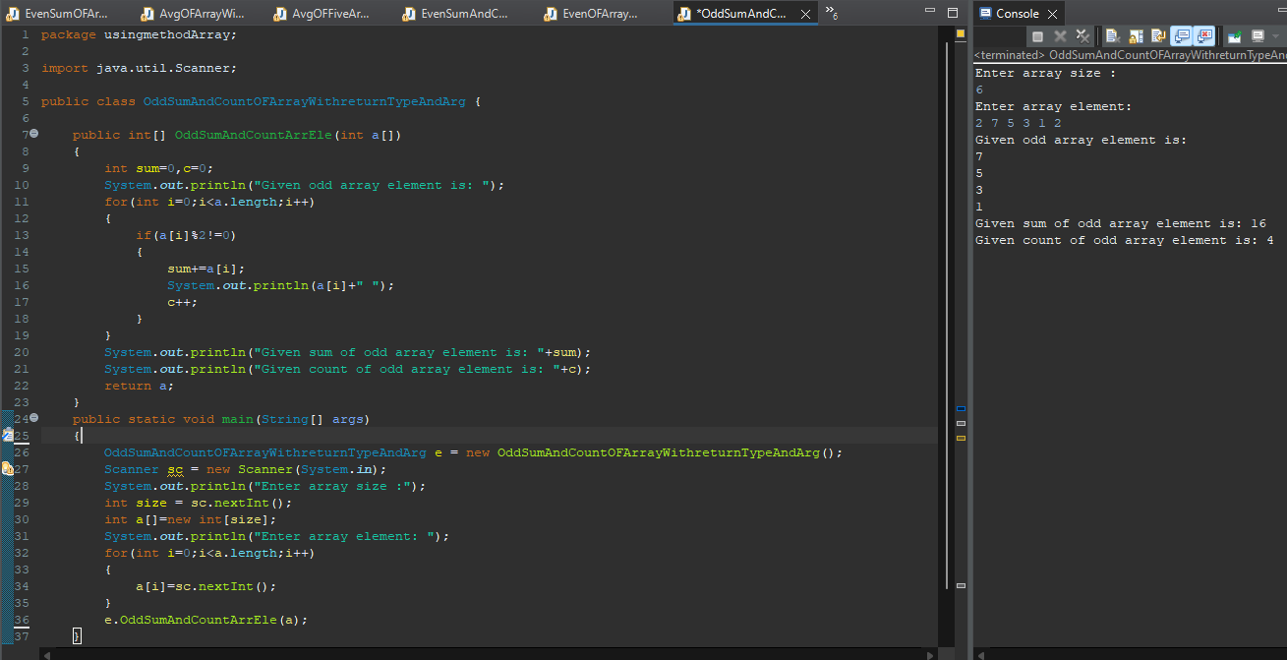

**Q17. Write a program to enter an array and print element present at odd position and also find count.**

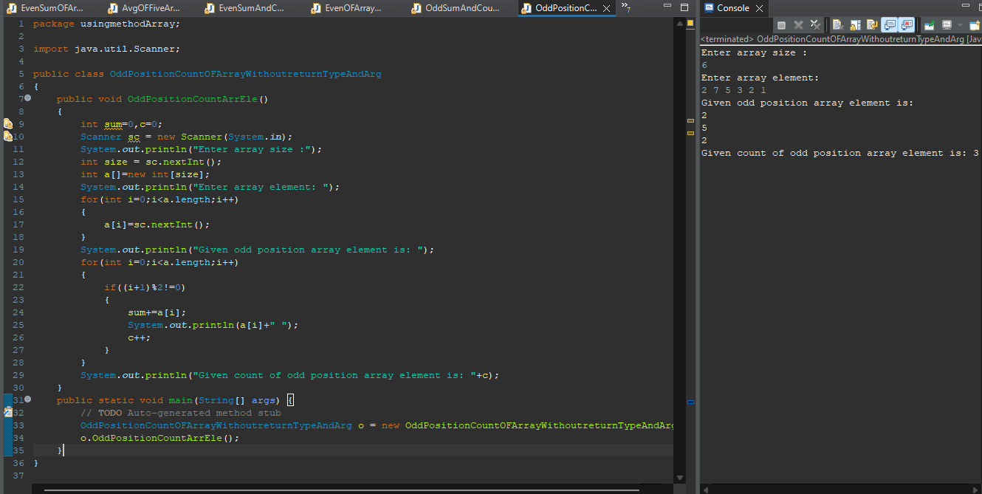

**Q18. Write a program to enter an array and print element present at even position and also find count.**

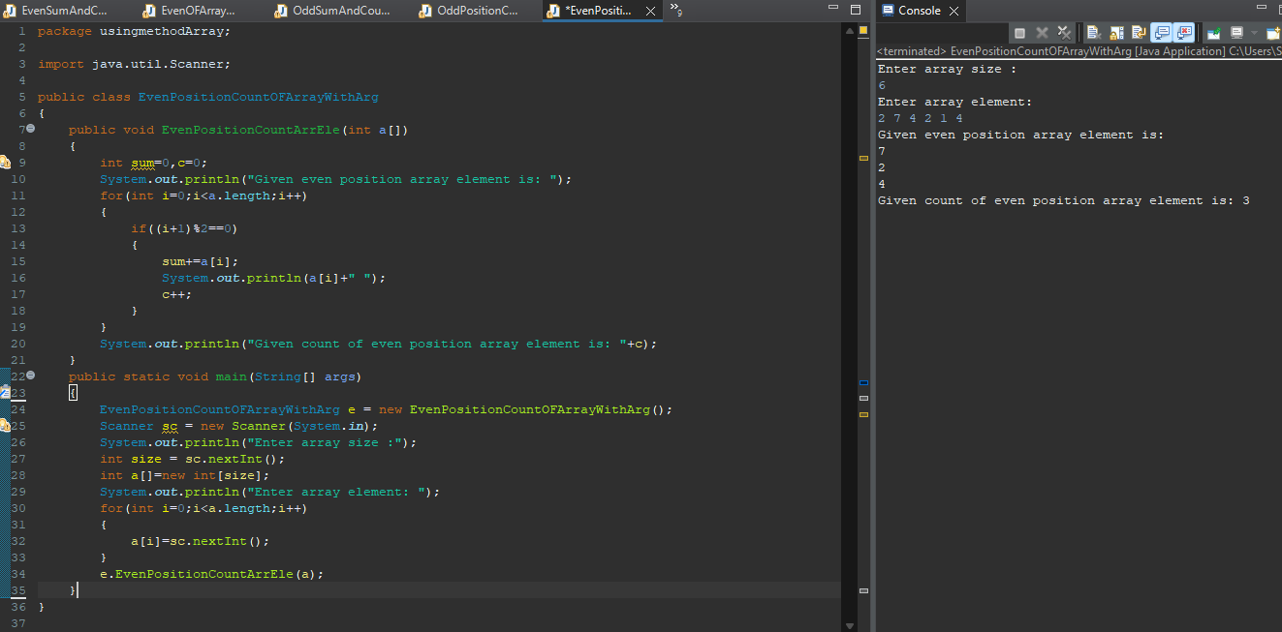

**Second Assignment:**

**Q1. Write a program to enter an array and find the sum and count of element present at even position.**

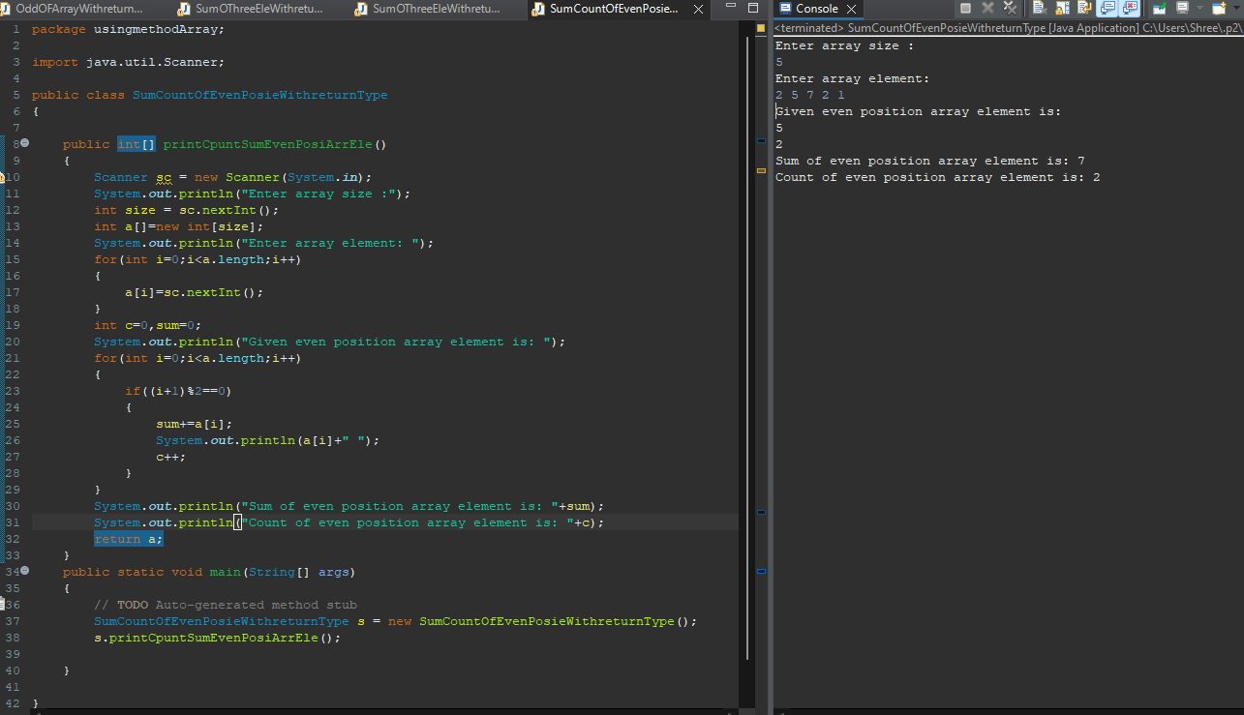

**Q2. Write a program to enter an array and find the sum and count of odd element.**

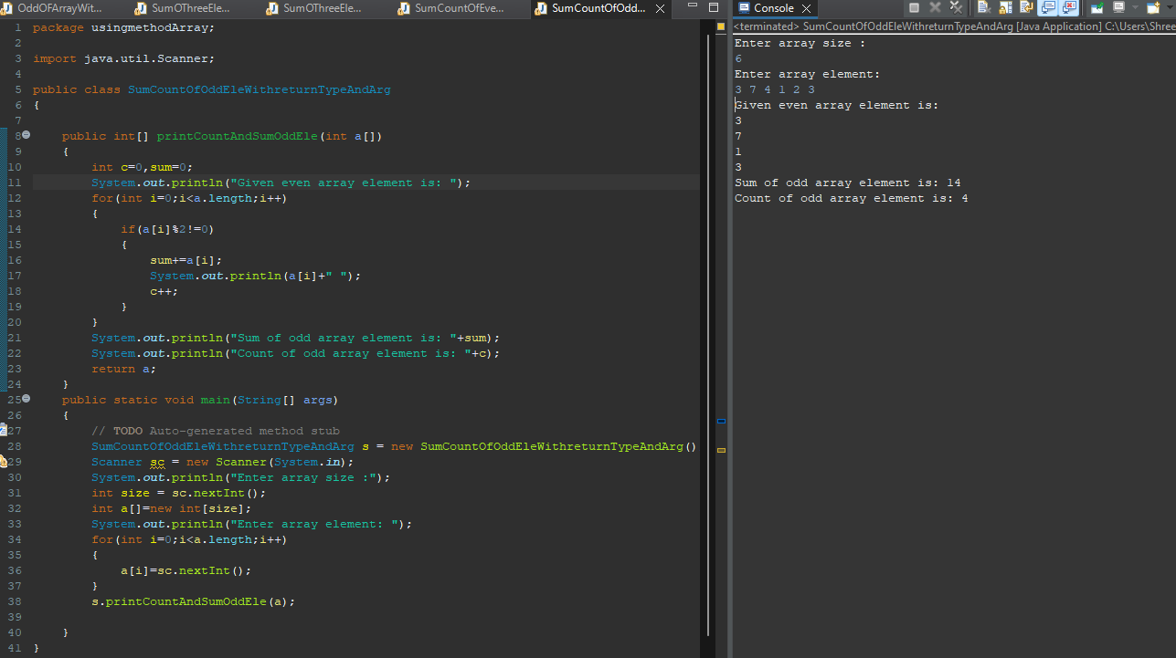

**Q3. Write a program to replace all the 0’s with 1’s in your array. Your array is [26, 0, 67, 45, 0, 78, 54, 34, 10, 0,34].**

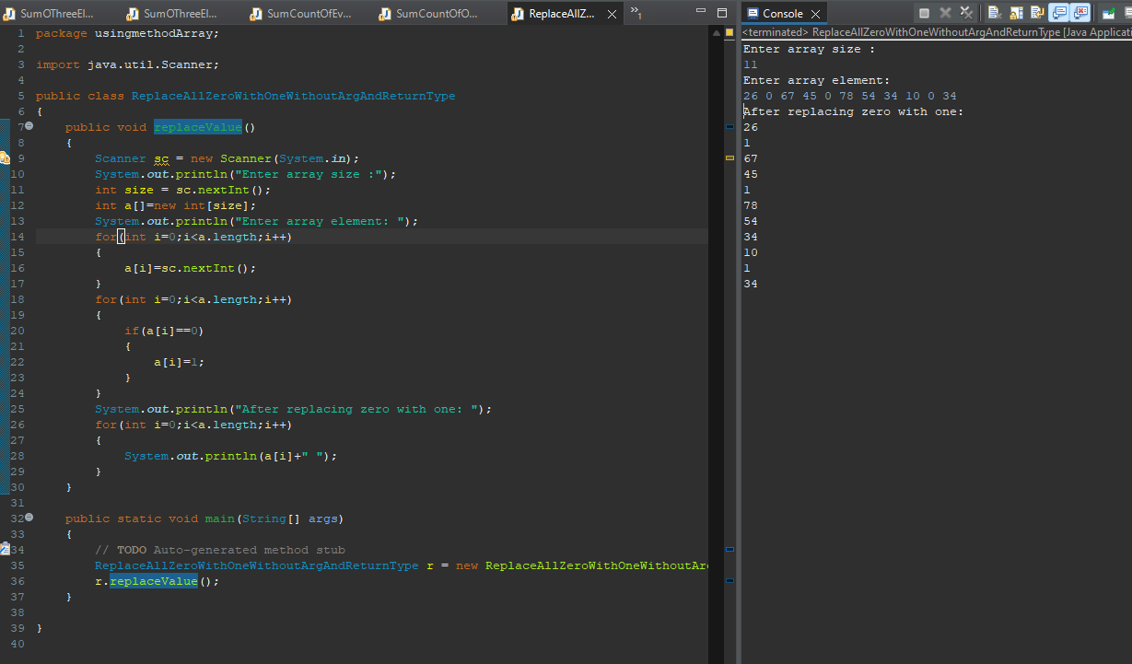

**Q4. Write a program to enter an array and search any particular element and find the count.**

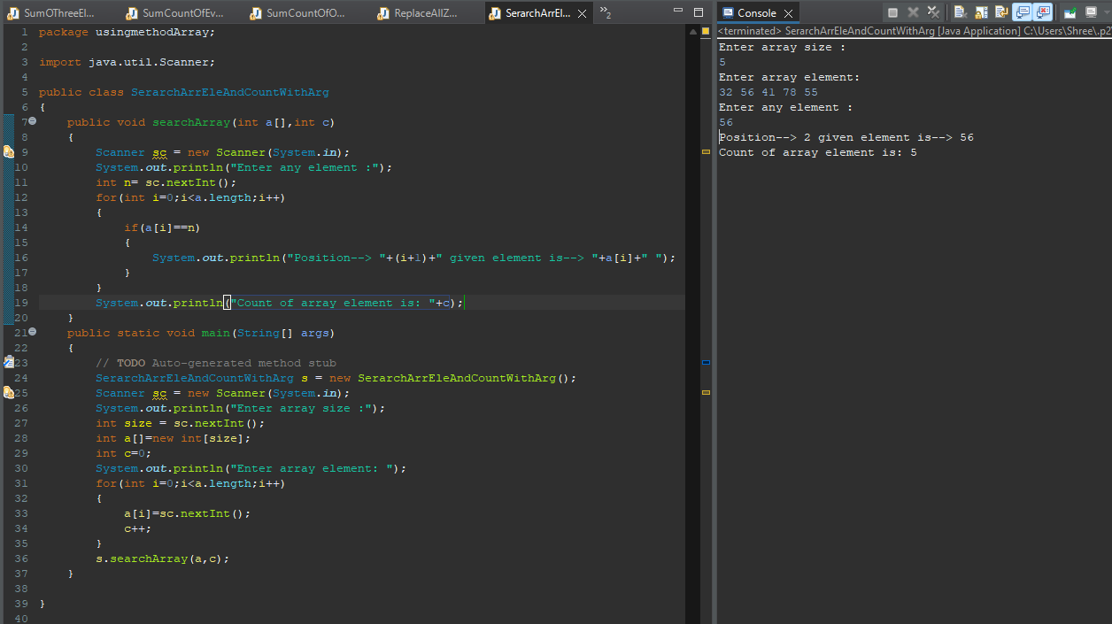

**Q5. Write a program to check if an array of integers contains two specified elements.**

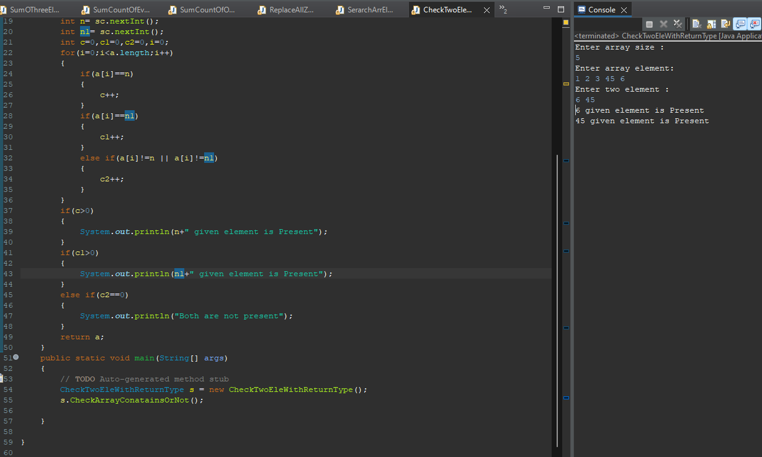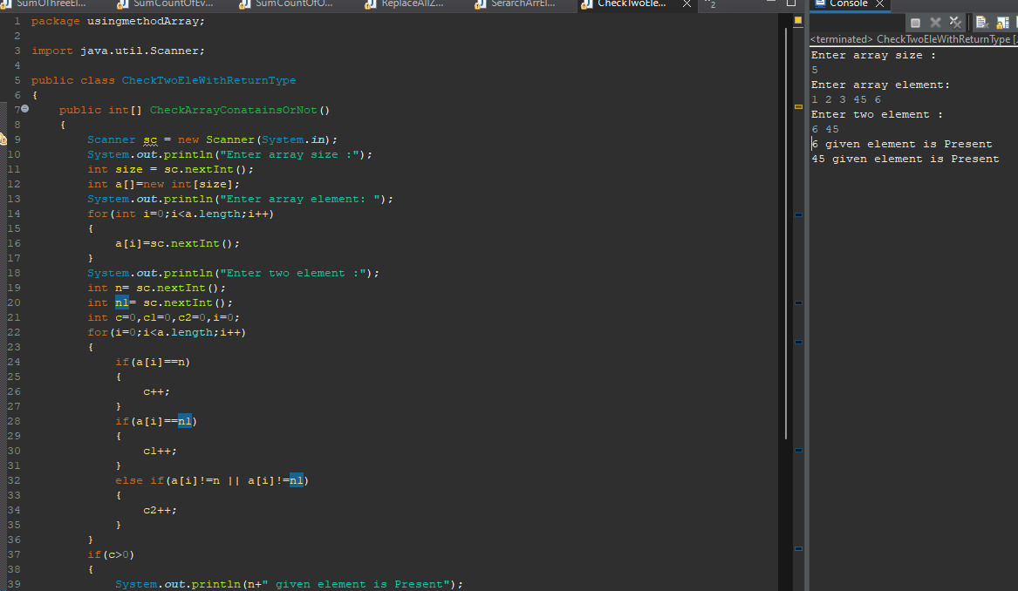

**Q6. Write a program to enter an array and find the duplicate element and also count of that.**

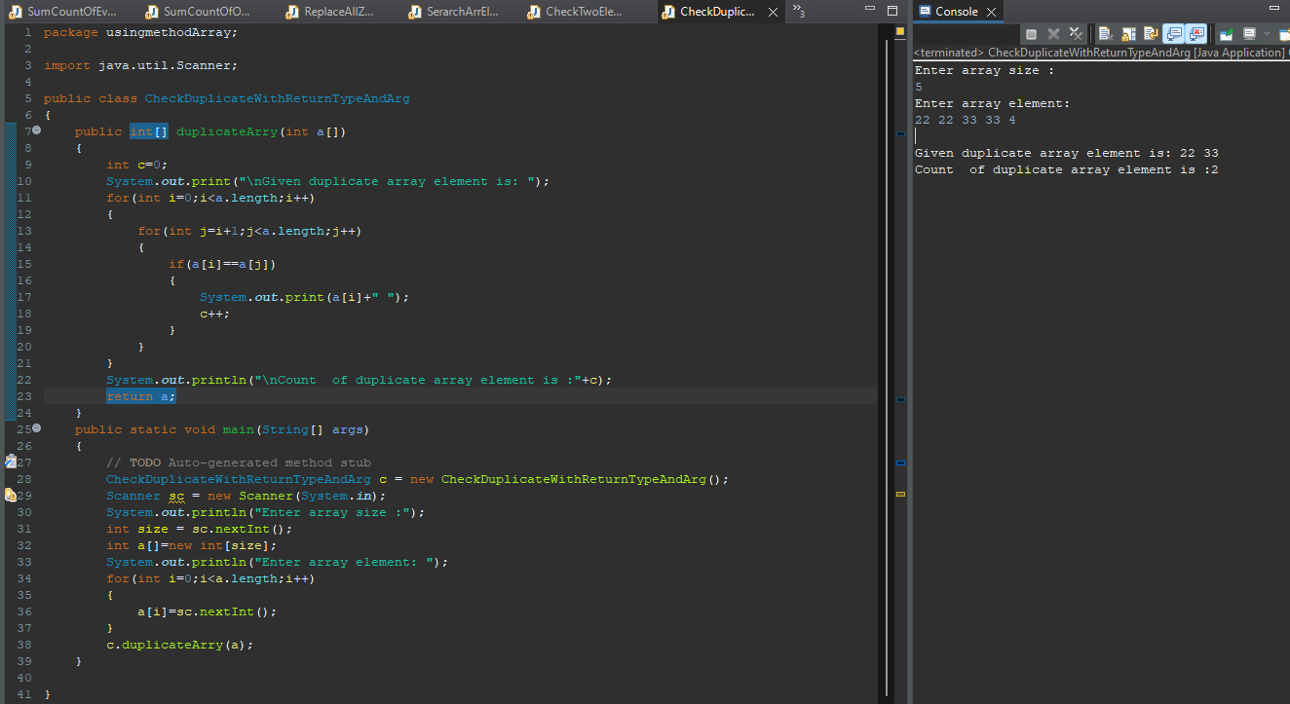

**Q7. Write a program to enter an array and print the square of the element which is on odd position.**

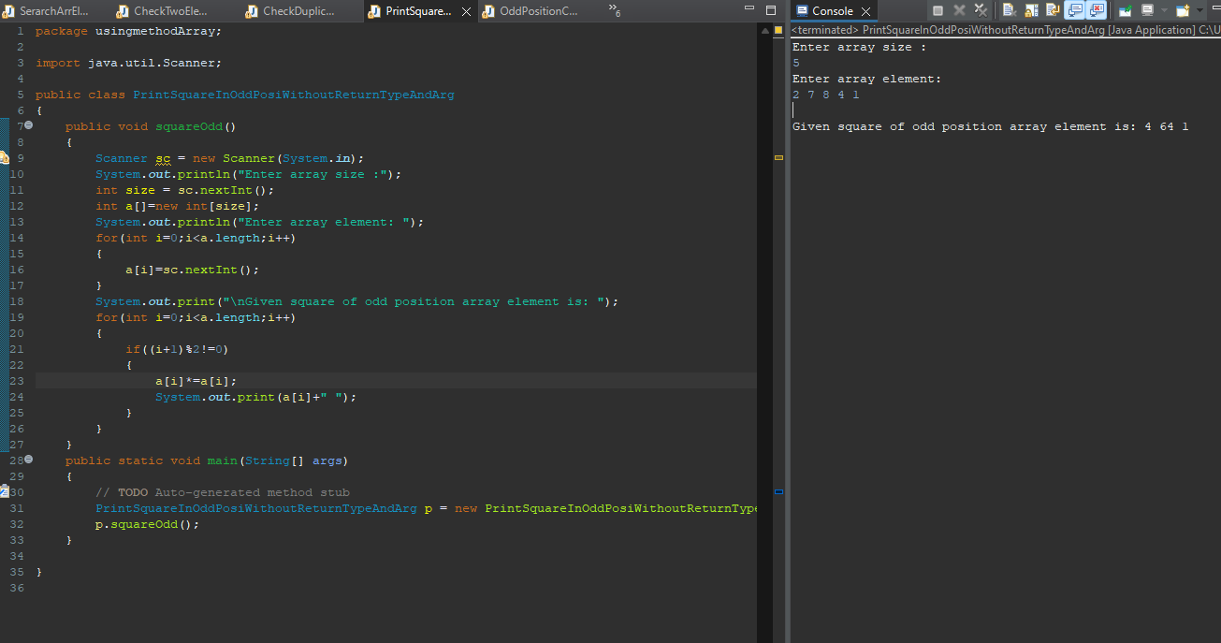

**Q8. Write a program to enter an array and print the square of the element which is on even position.**

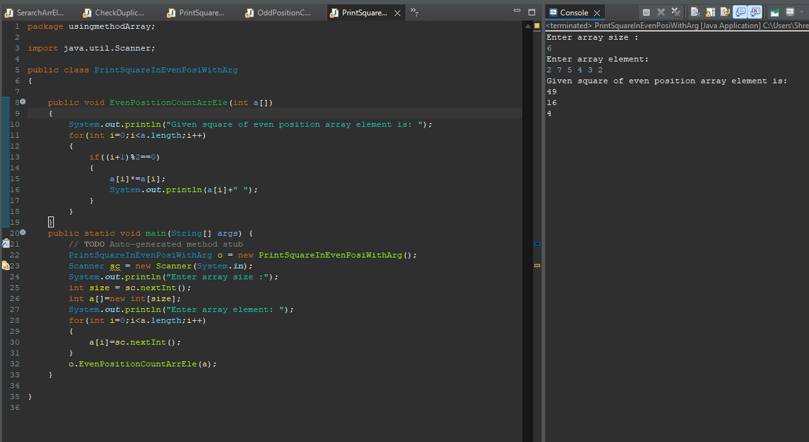

**Q9. Write a program to to replace all negative value with its immediate left elements square. Means arr[] = [12, 3, -19, 29, 5, -61, 44, 7, -9] Output array will be [12, 3, 9, 29, 5, 25, 44, 7, 49].//i=3a [i-1]**

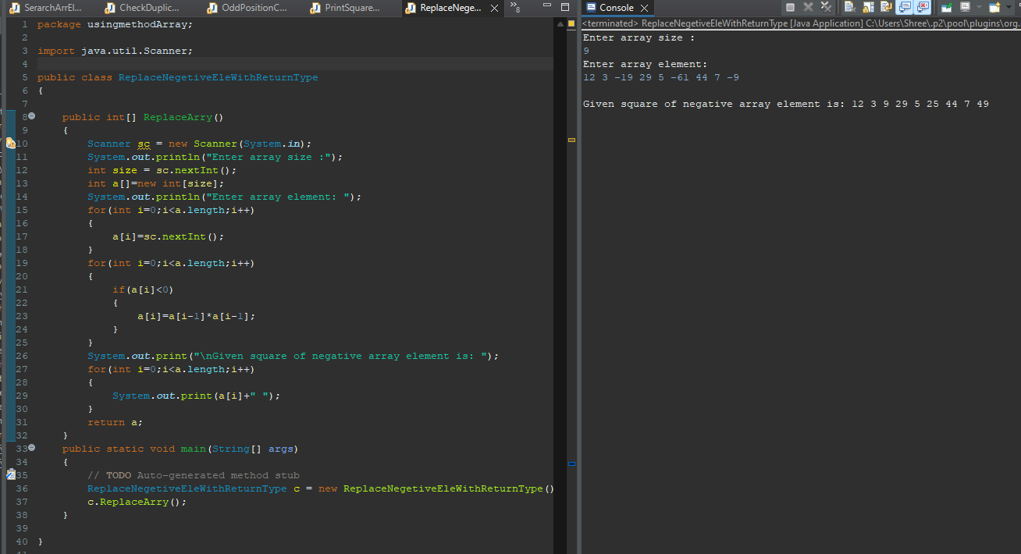

**Q10. Write a program to enter an array and print it in reverse order.**

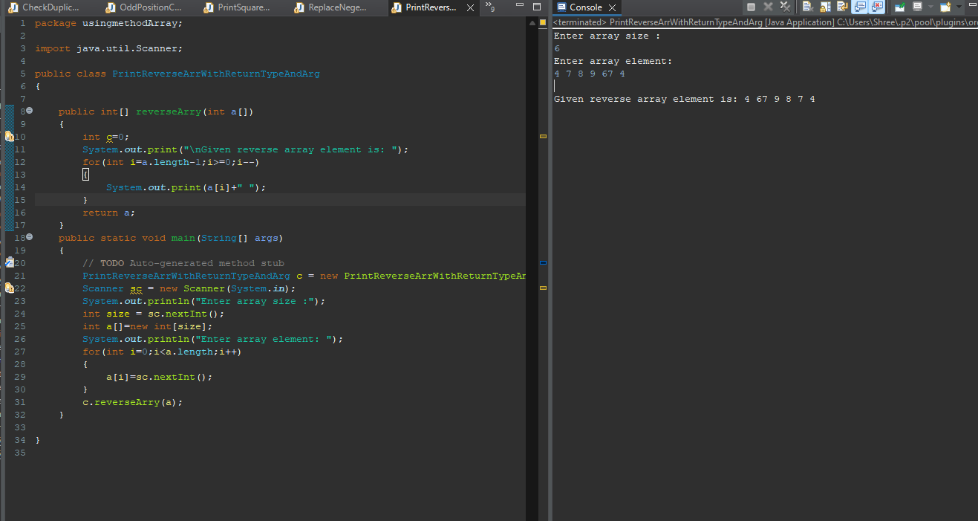

**Q11. Write a program to enter an array and find the no in array which is equal to the sum of 1st and last element.**

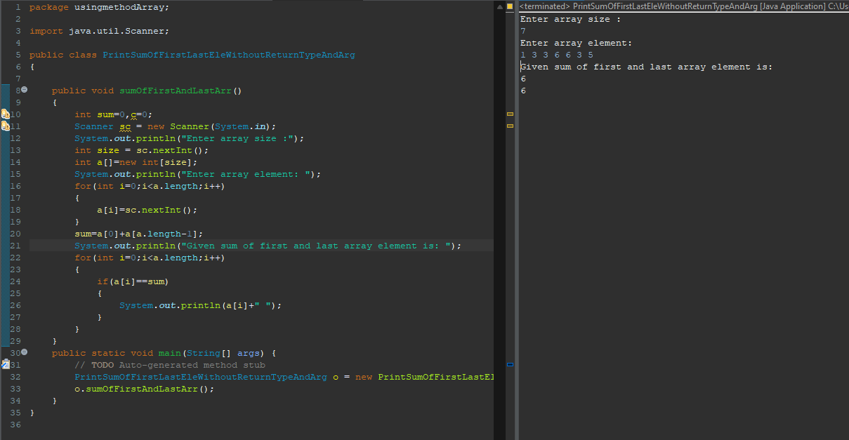

**3rd Assignment**

**Q1. Write a program to merge two Array and print the final array.**

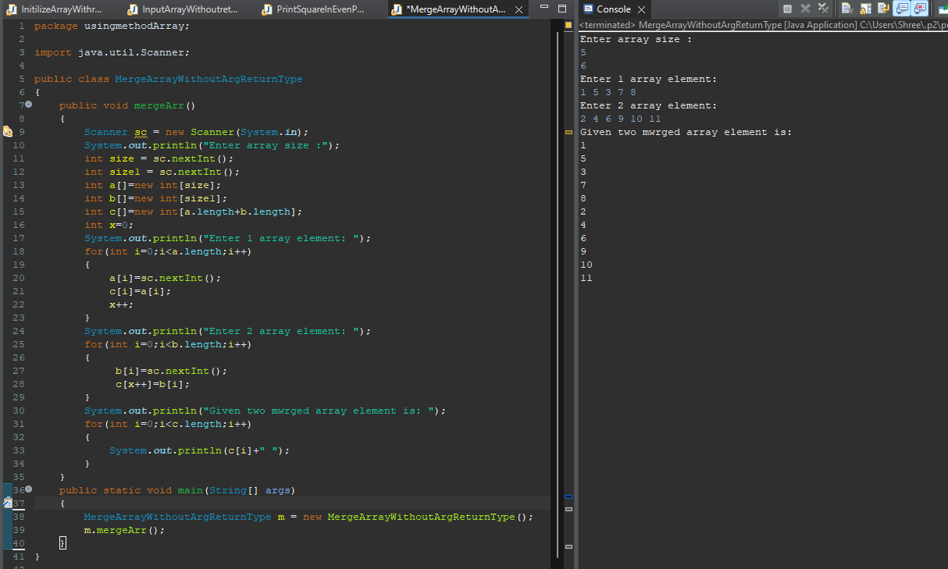

**Q2. Write a program to enter an array and sort that in ascending order.**

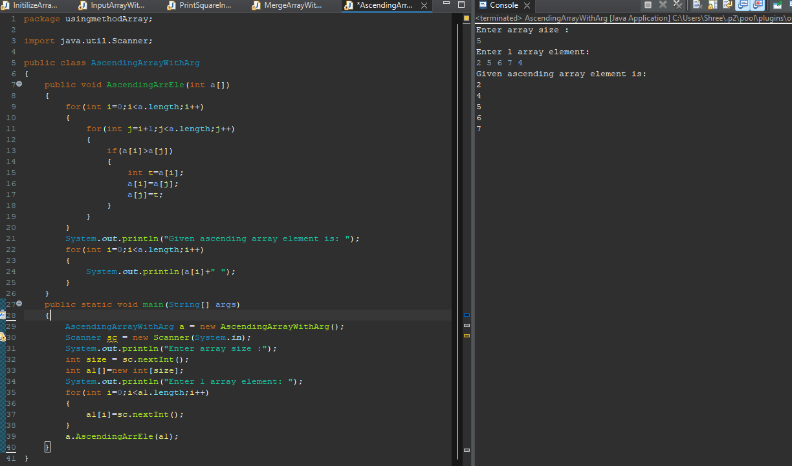

**Q3. Write a program to enter an array and sort that in descending order.**

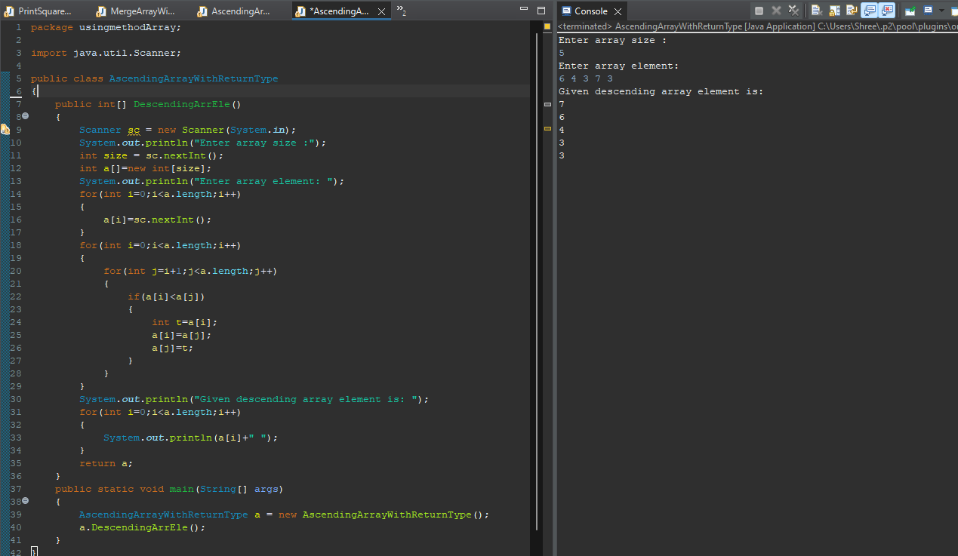

**Q4. Write a program to enter an array and find the second max element.**

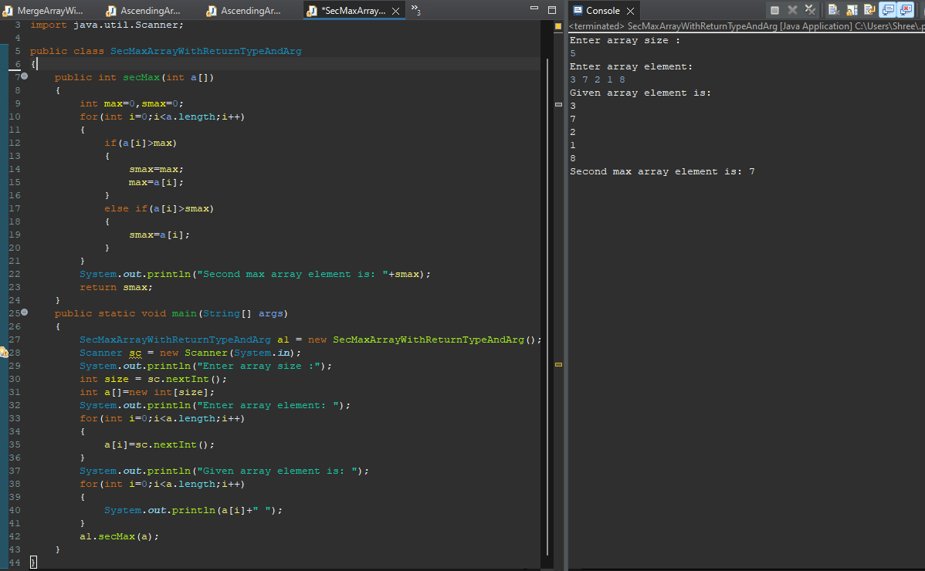

**Q5. Write a program to enter an array and find the second min element.**

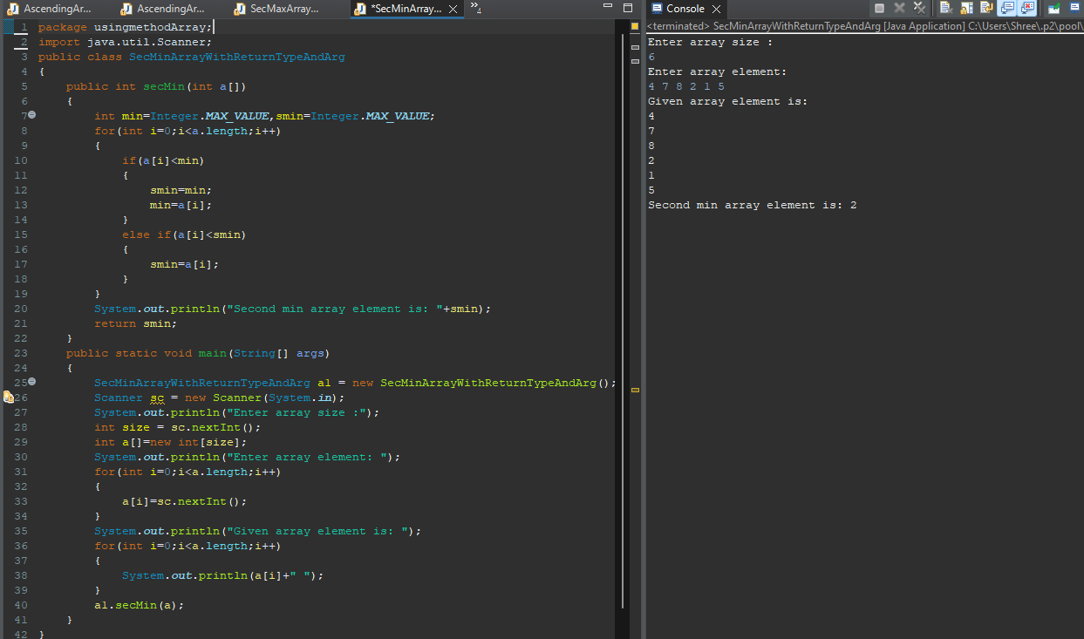

**Q6. Write a program to enter an array and find max and min element.**

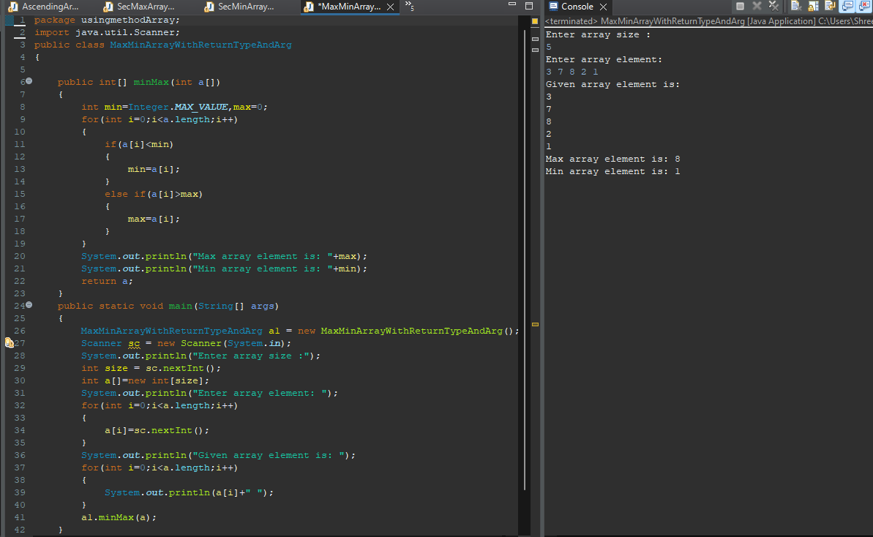

**Q7. Write a program to input 10 elements in float and print it.**

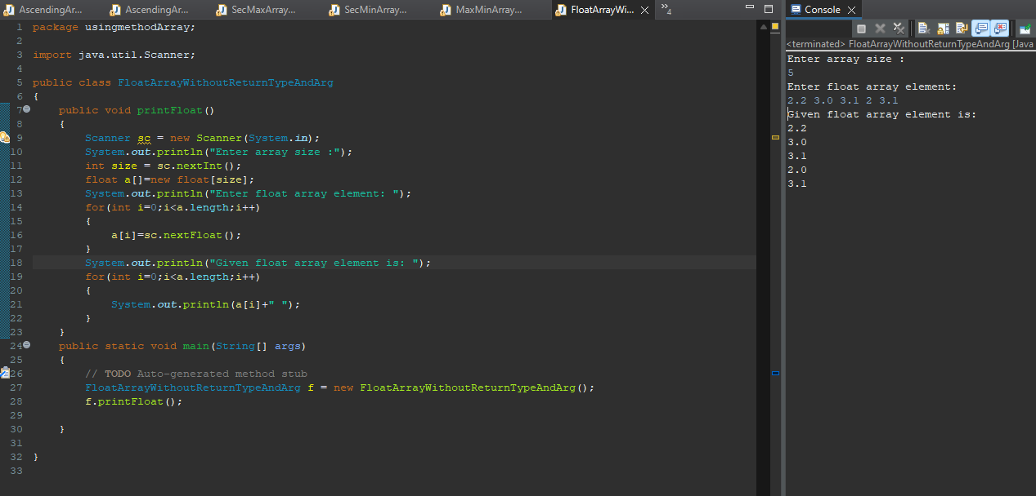

**Q8. Write a program to input 10 name and print with index, name.**

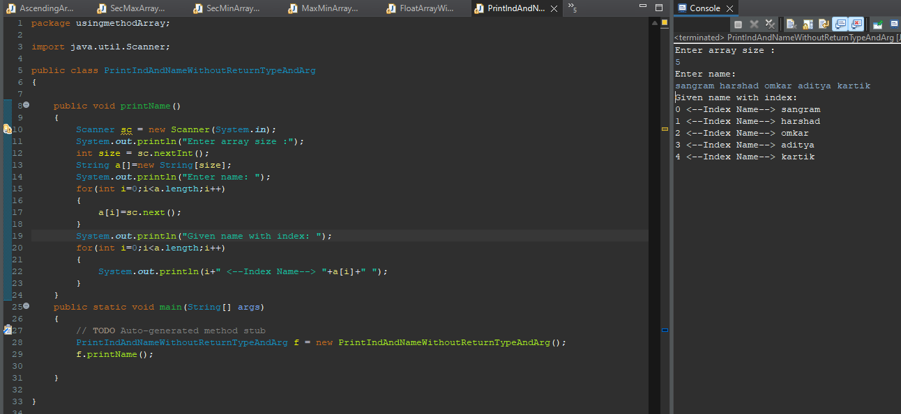

**Q9. Write a program to input an array and print it.**



**Q10. Write a program initialize an array and print it.**



**Q11. Write a program to input 10 elements and multiply 5th elements by 25.**

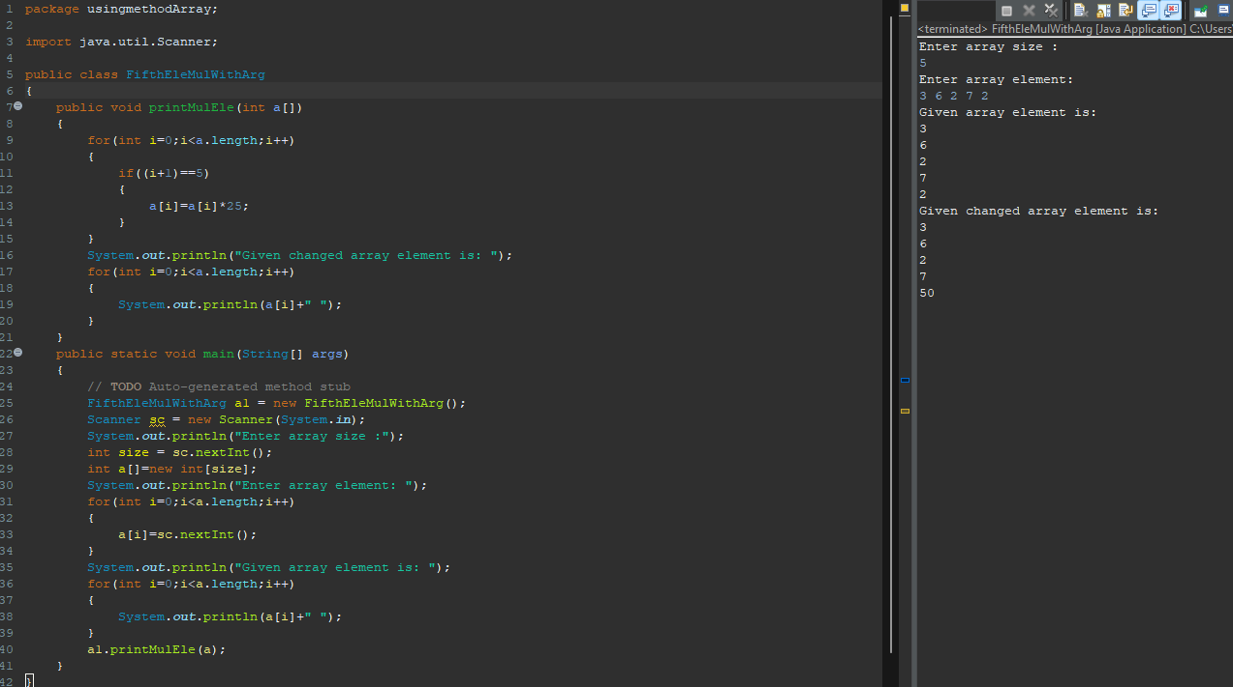

**Q12. Write a program to input an array and find its average of first 5 element.**



**Q16. Write a program enter an array and print the square of the element which is present at odd position.**



**Q17. Write a program to enter an array and print the square of the element which is present at even position.**



**Q18. Write a program to input two array and merge in third array.**



**Q19. a[]={10,20,30,40,50}, b[]={1,2,3,4,5}**

**output array=c[]={10,5,20,4,30,3,40,2,50,1}**

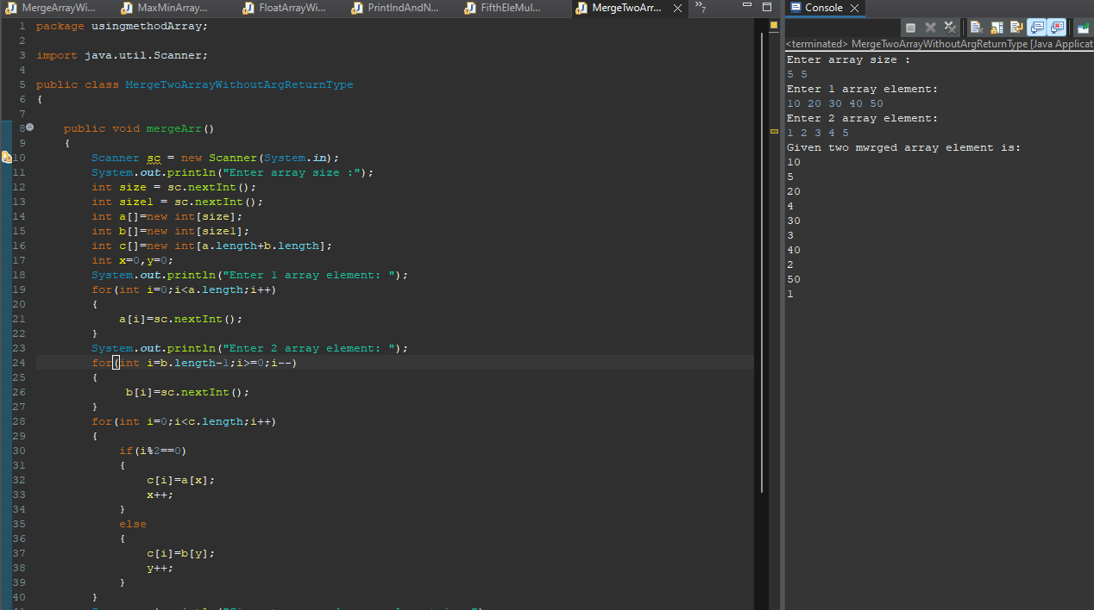

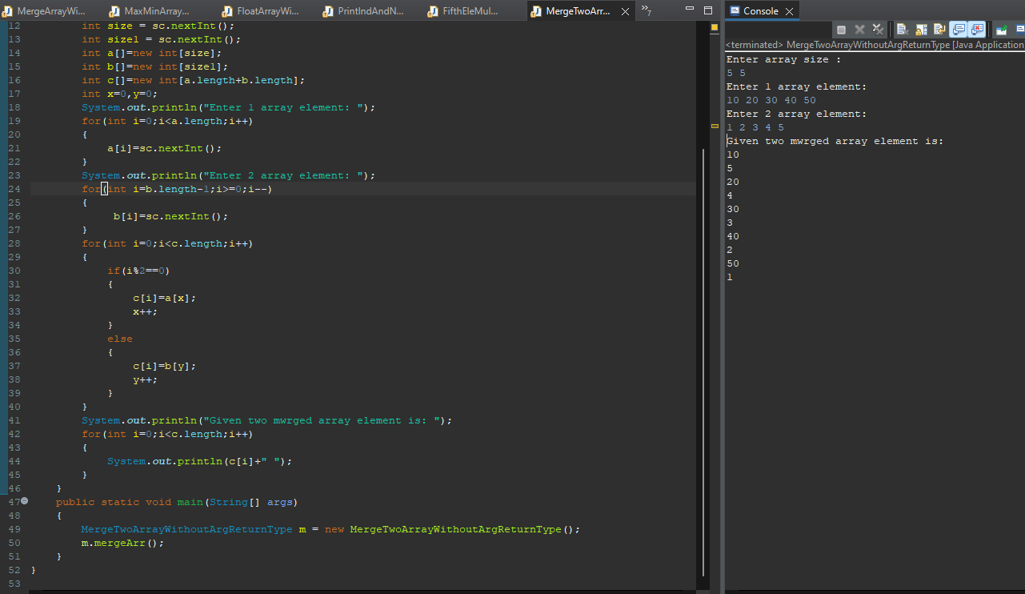

**Q20. Write a program sort half array in ascending and half in descending order**

**input= int [] a={9,1,3,5,6,11,22,66,10,19}. output={1,3,5,6,9,10,66,22,19,11,10}**

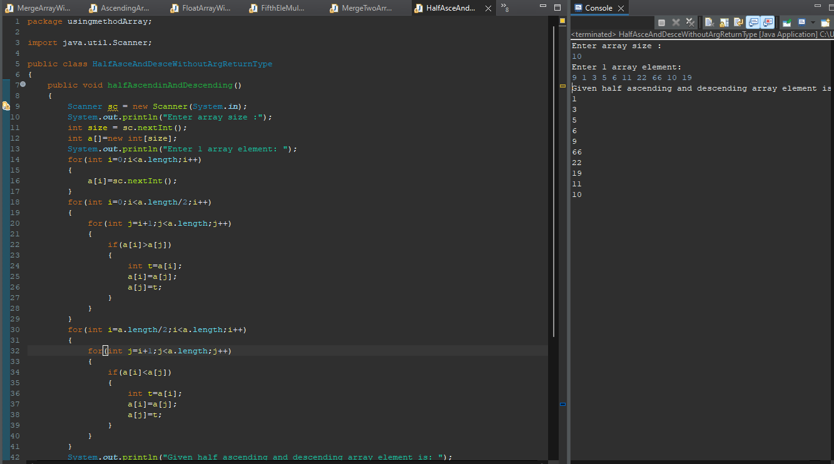

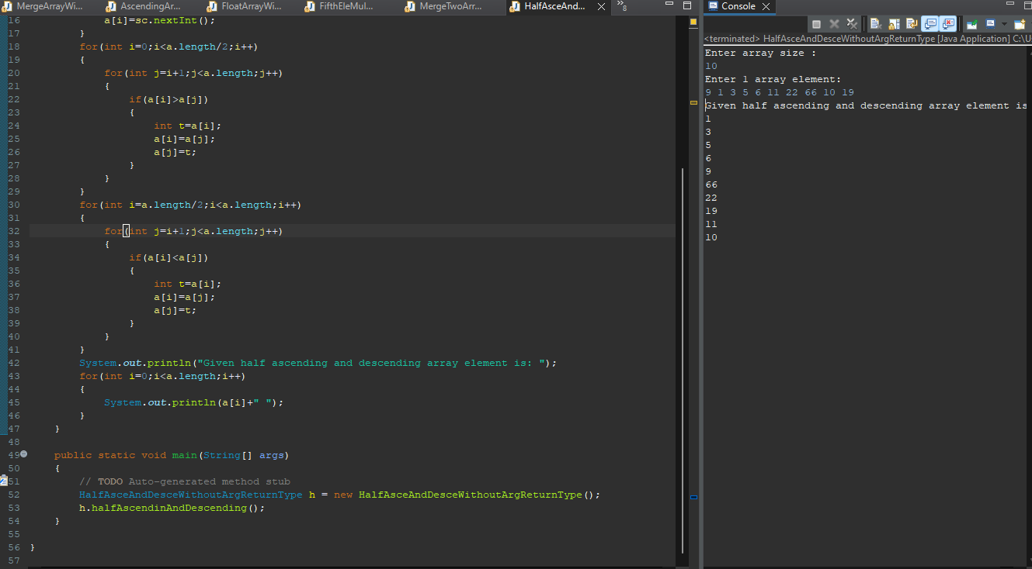

**4th Assignment**

**Q1. Write a program to check if an array of integers without 0 and -1.**

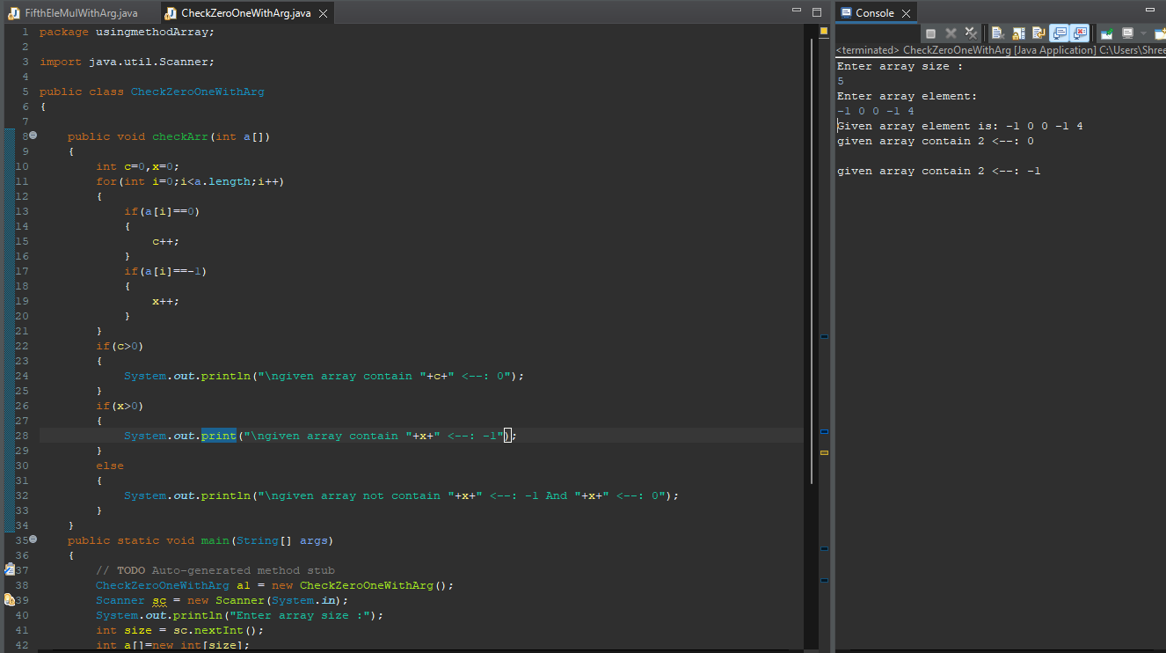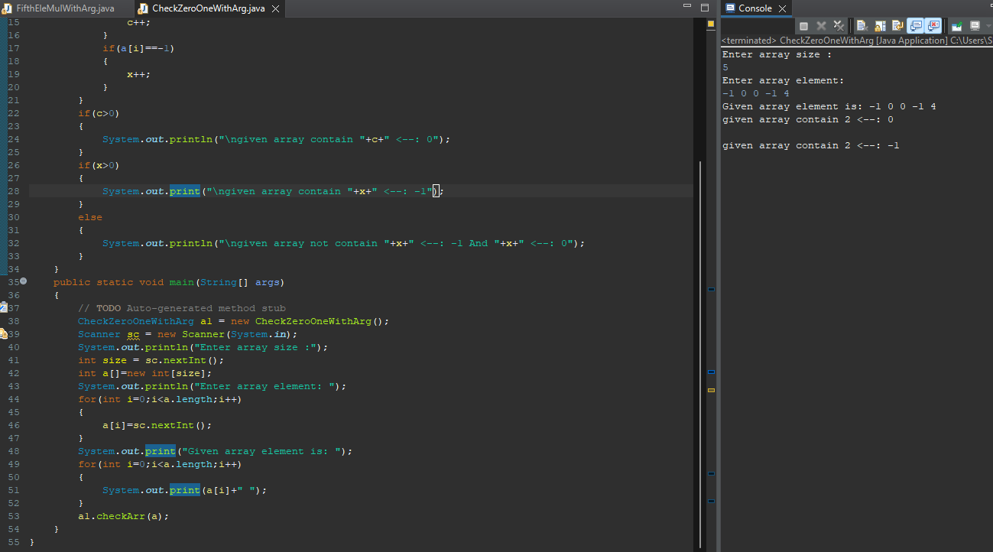

**Q2. Write a Java program to remove the duplicate elements of a given array and print the new length of the array. Sample array: [20, 20, 30, 40, 50, 50, 50].After removing the duplicate elements the program should return 4 as the new length of the array.**

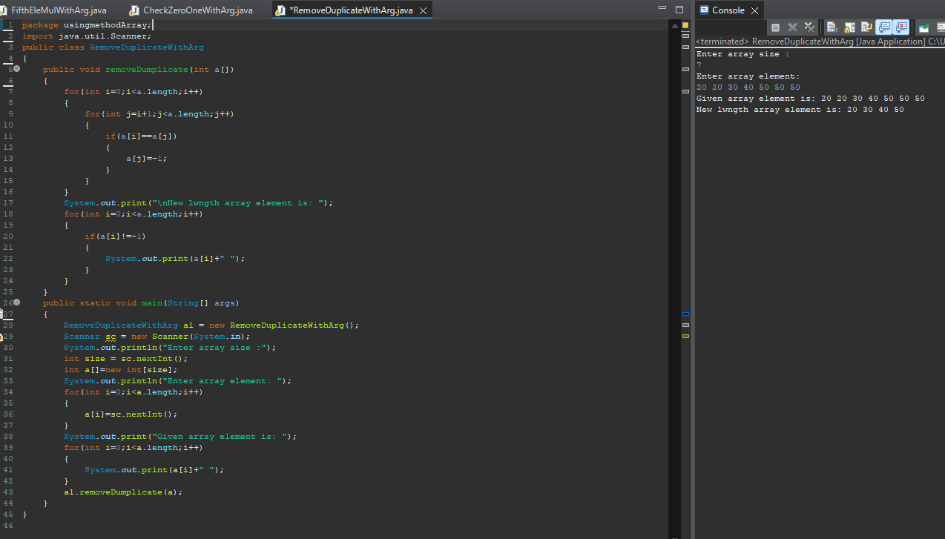

**Q3. Write a Java program to find the sum of the two elements of a given array which is equal to a given integer. Sample array: [1, 2, 4, 5, 6]Target value: 6.**

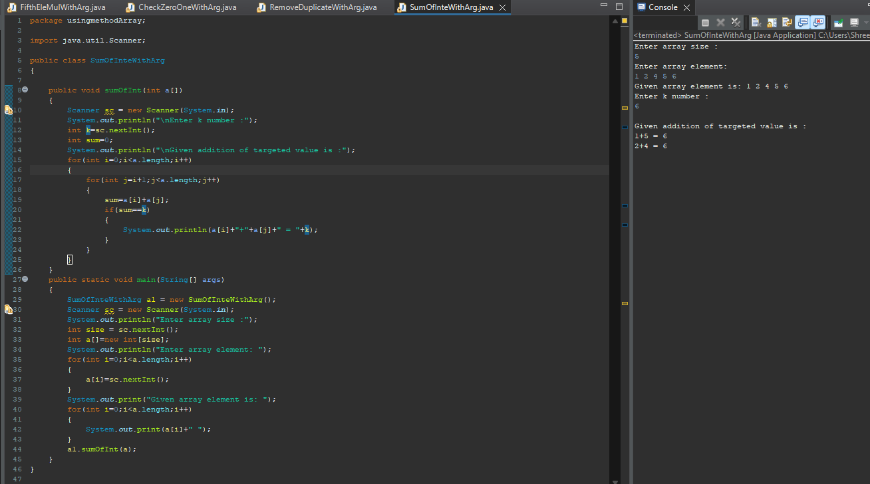

**Q4. Write a Java program to print all the LEADERS in the array.**

**Note: An element is leader if it is greater than all the elements to its right side.**

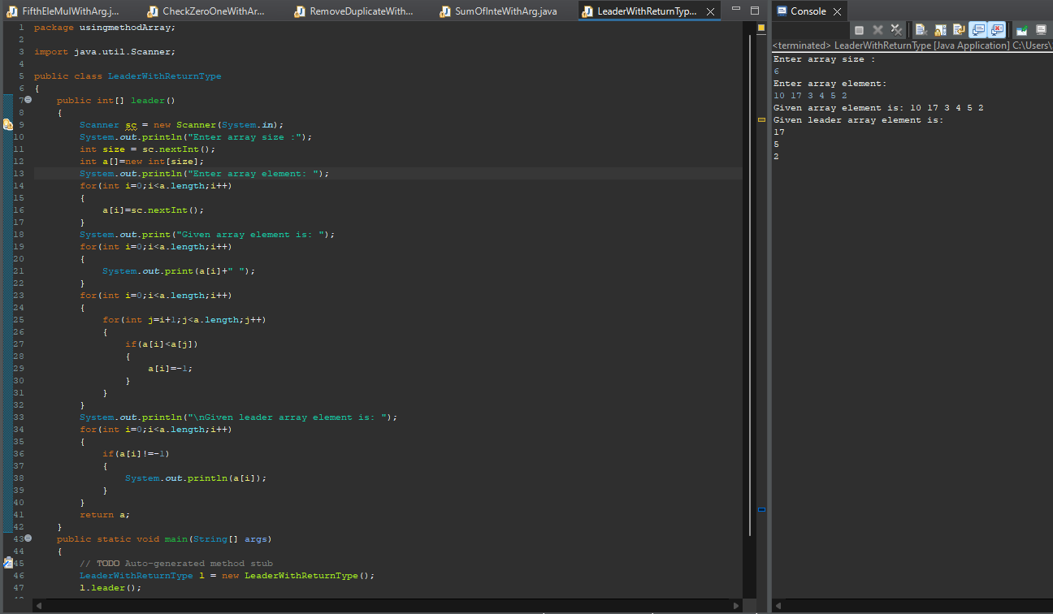

**Q5. Write a Java program to check if an array of integers contains two specified elements 65 and 77.**

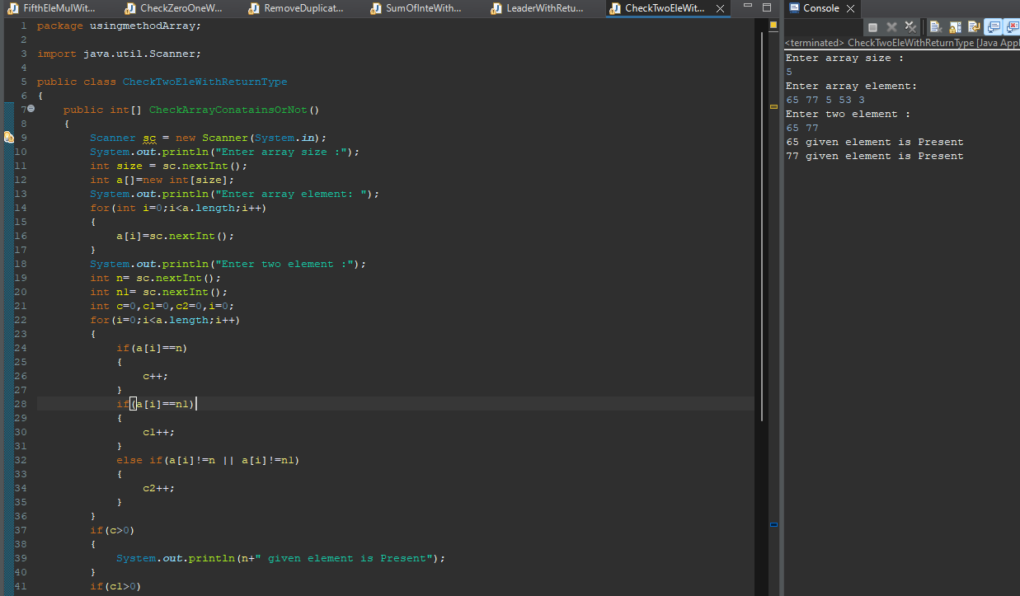

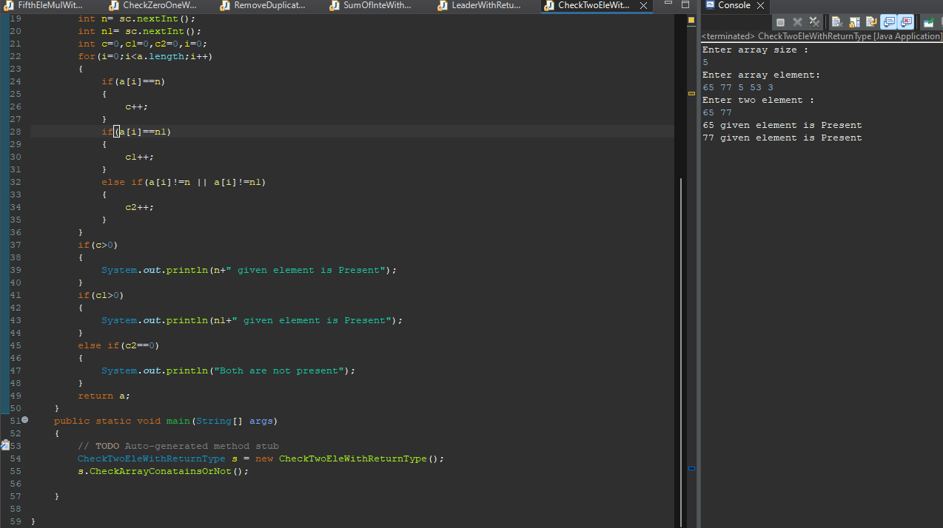

**Q6. Write a Java program to separate even and odd numbers of a given array of integers. Put all even numbers first, and then odd numbers.**

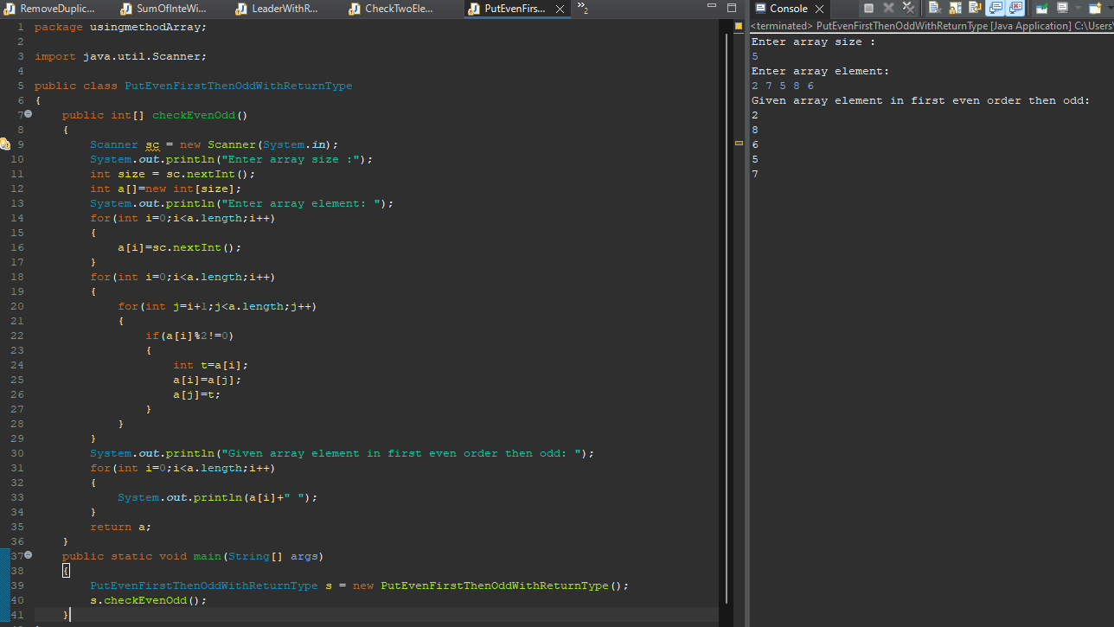

**Q7. Write a java program to find prime number between an arrays of element.**

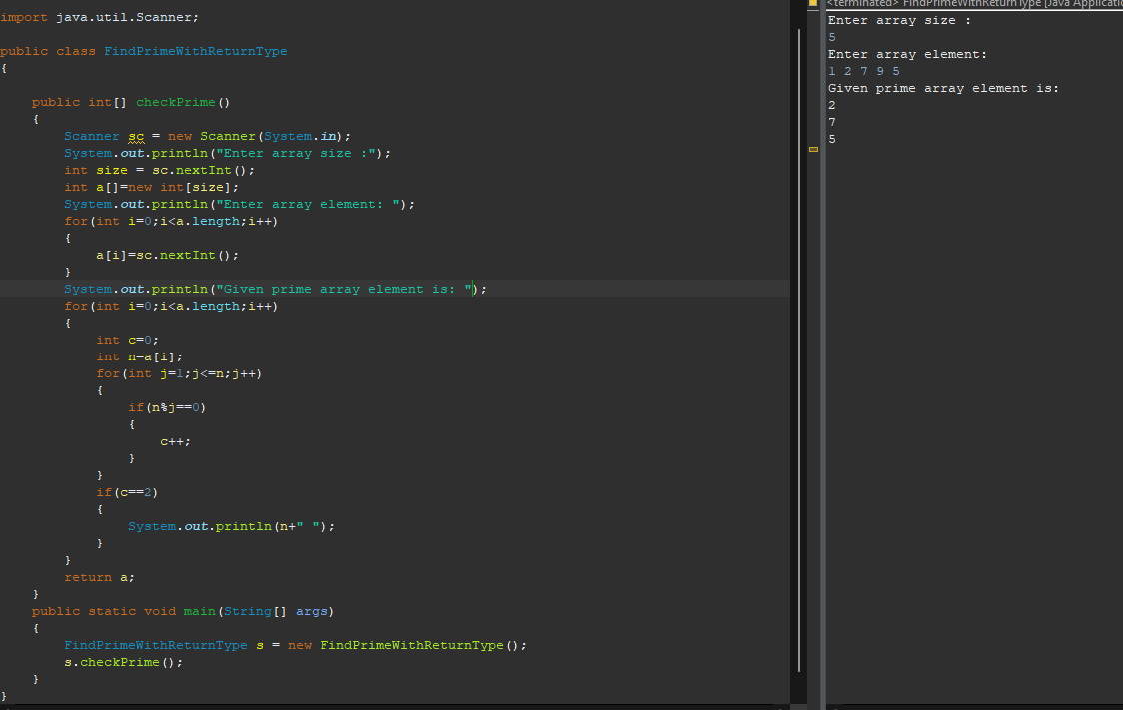

**Q1.Given an array and a number K where K is smaller than the size of the array. Find the K’th smallest element in the given array. Given that all array elements are distinct.**

**Examples: Input: arr[] = {7, 10, 4, 3, 20, 15}, K = 3 Output: 7**

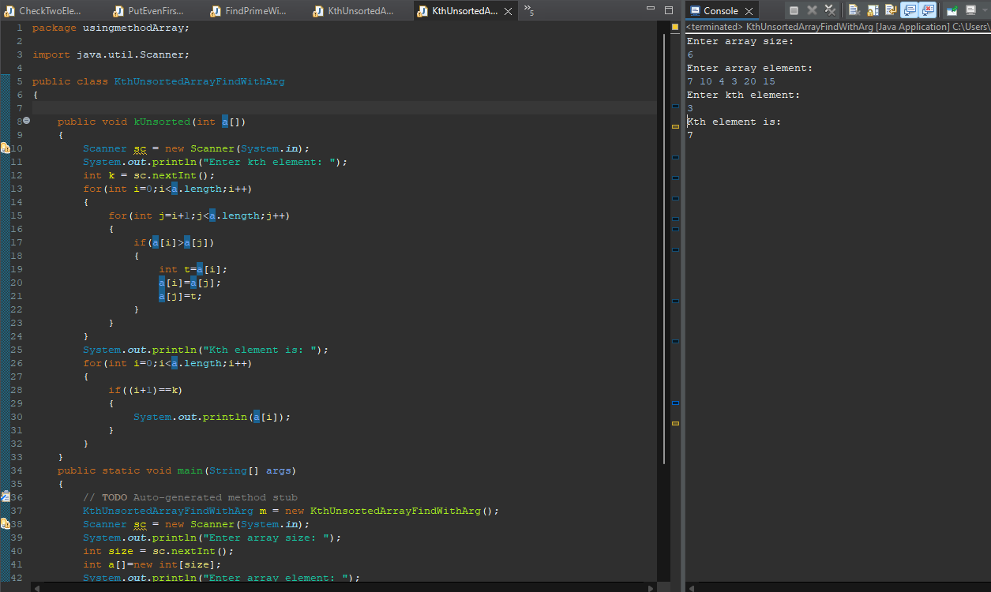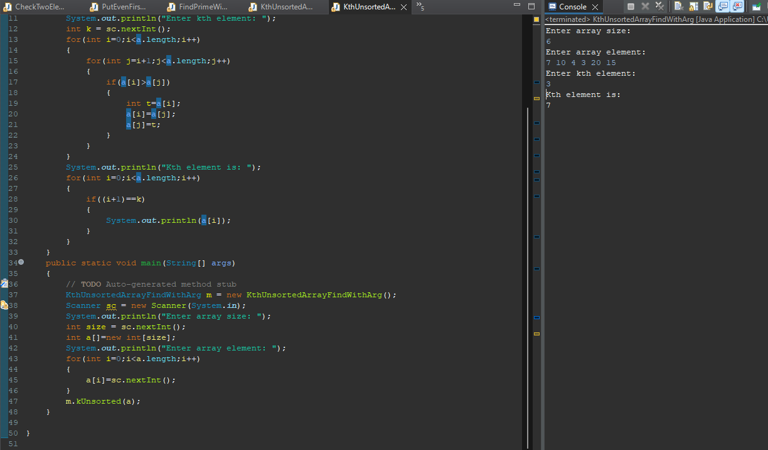

**Q2.Given an array of integers arr[], The task is to find the index of first repeating element in it i.e. the element that occurs more than once and whose index of the first occurrence is the smallest.**

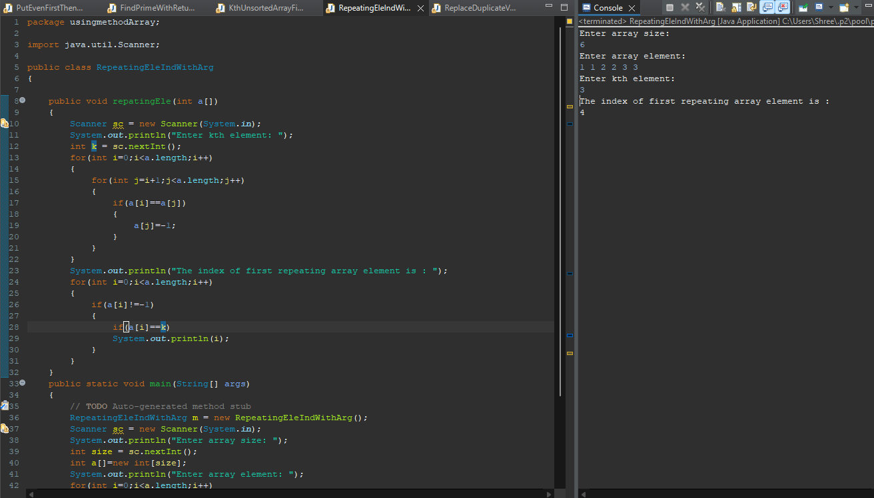 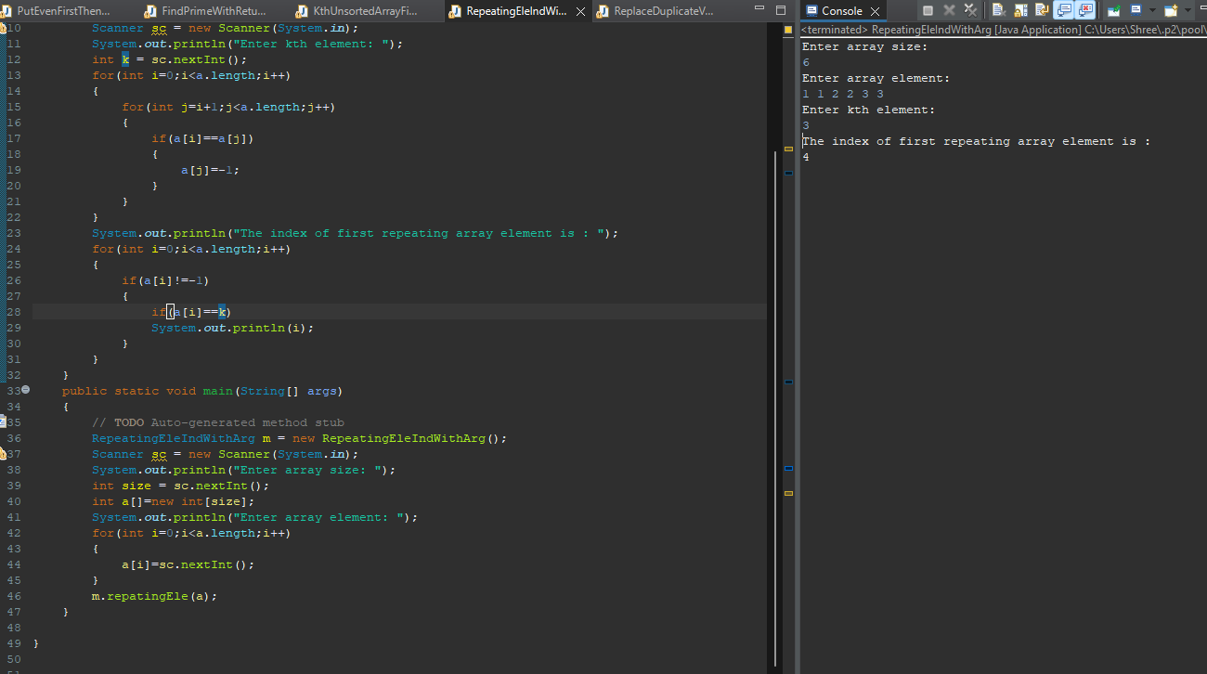

**Q3. Find the majority element in the array. A majority element in an array A[] of size n is an element that appears more than n/2 times (and hence there is at most one such element).**

**Examples : Input : {3, 3, 4, 2, 4, 4, 2, 4, 4},Output : 4 Explanation: The frequency of 4 is 5 which is greater than the half of the size of the array size.**

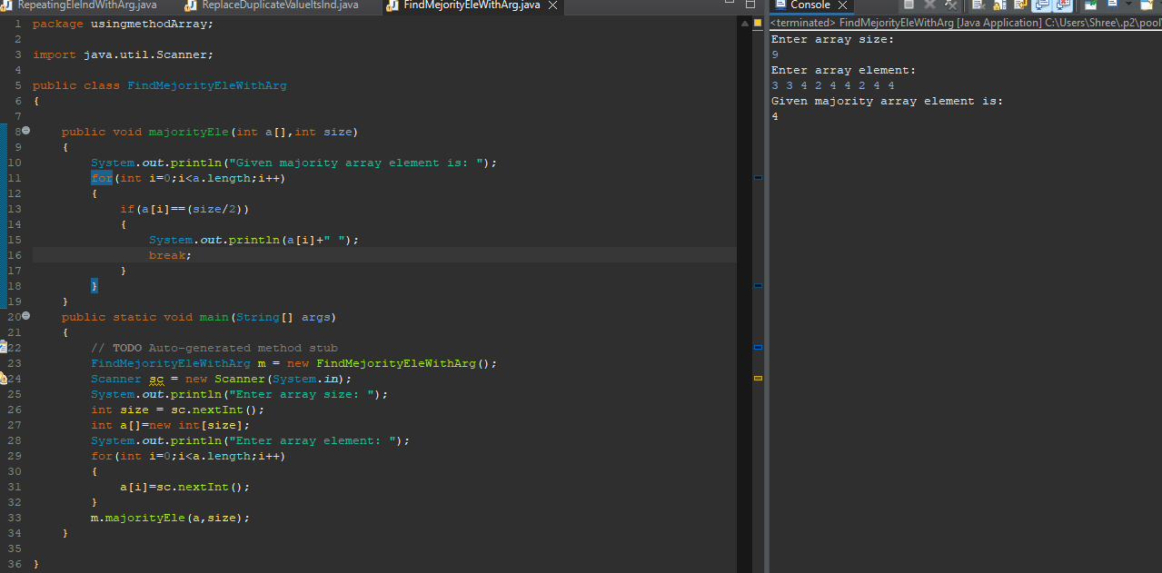

**Q4.Given an array of N integers, and a number sum, the task is to find the number of pairs of integers in the array whose sum is equal to sum.Examples: Input: arr[] = {1, 5, 7, -1}, sum = 6,Output: 2**

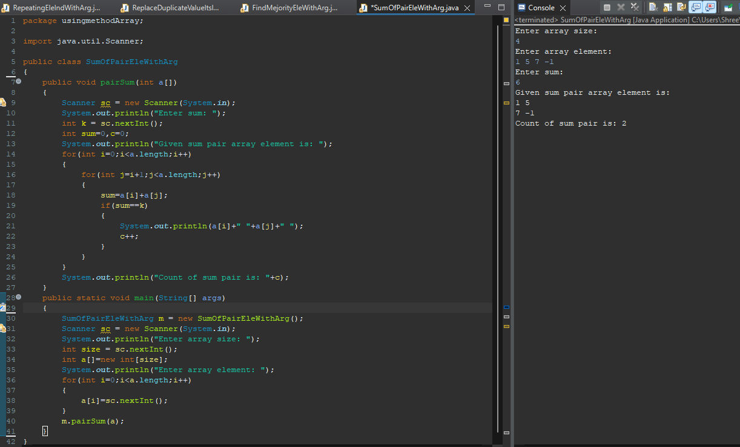

**Q5.Given an array and a value, find if there is a triplet in array whose sum is equal to the given value. If there is such a triplet present in array, then print the triplet and return true. Else return false. Examples: Input: array = {12, 3, 4, 1, 6, 9}, sum = 24, Output: 12, 3, 9**

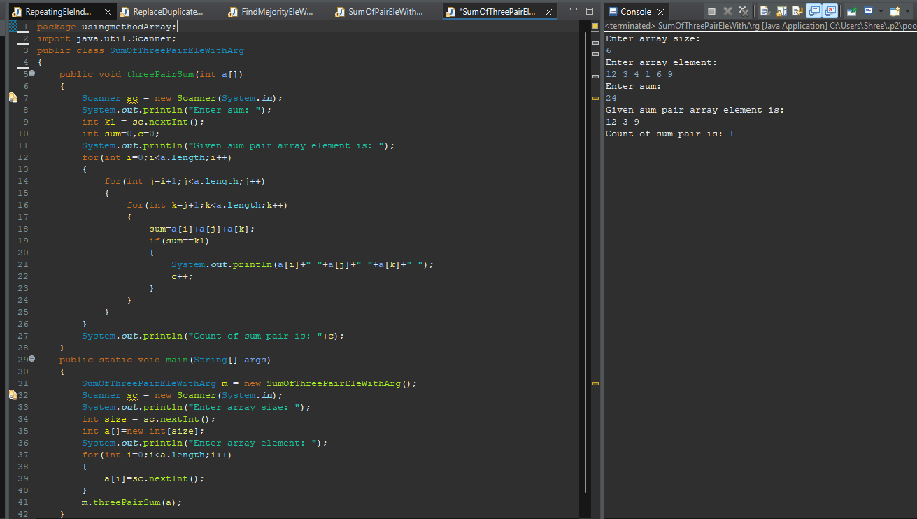

**Q3.a[]={10,20,30,40,50}, b[]={1,2,3,4,5}**

**output array=c[]={10,5,20,4,30,3,40,2,50,1}**

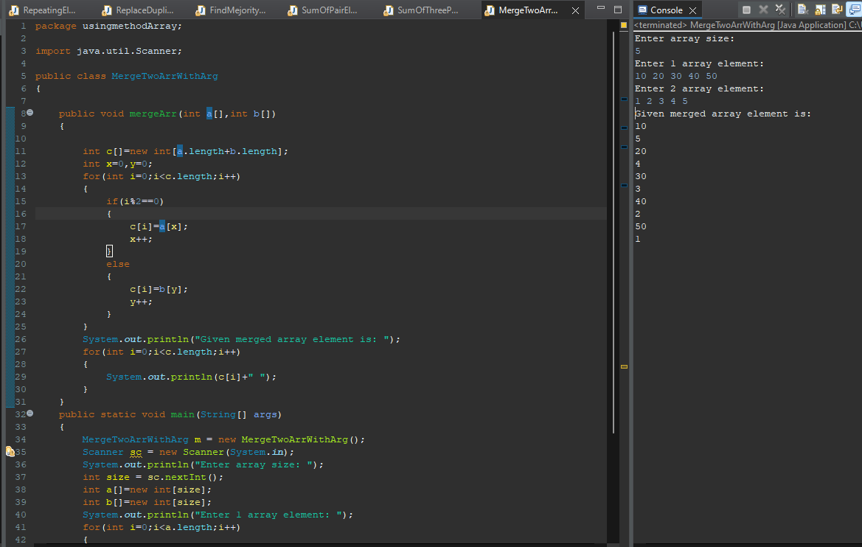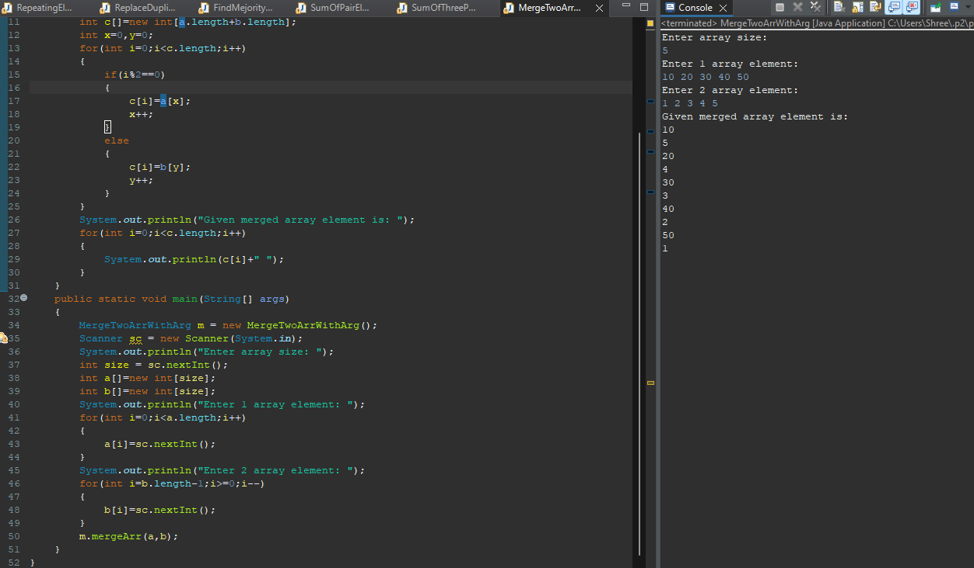

**Q4. Write a program to input an array now delete element from array, element is taken from user.**

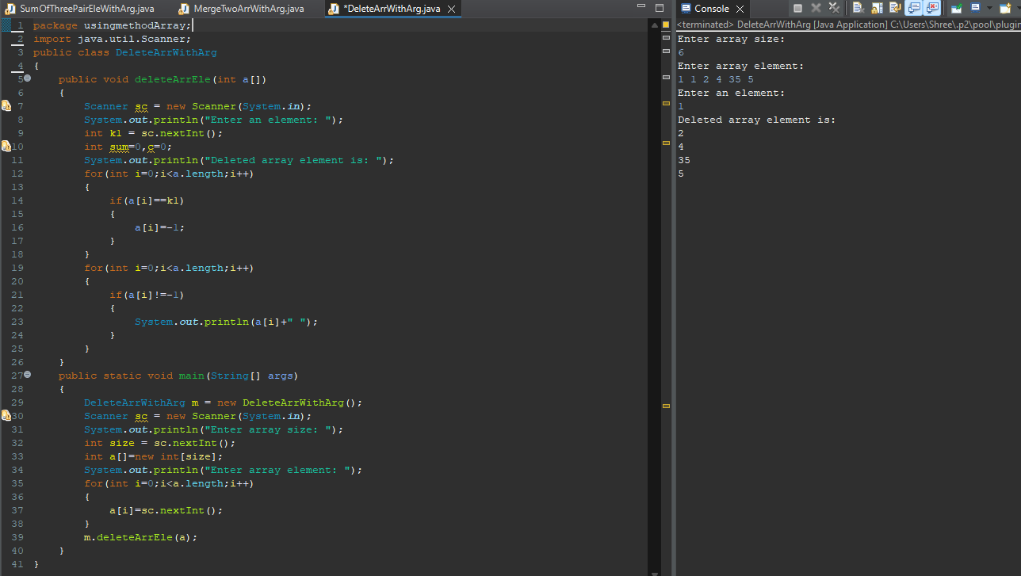

**Q5. Write a program to input an array now delete element from array, position is taken from user.**

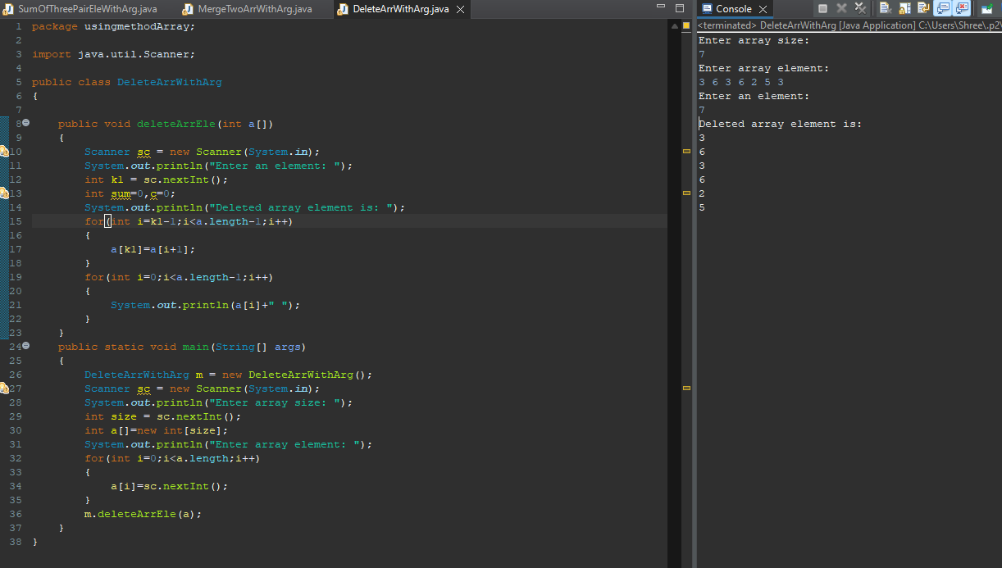

**Q5. Write a program to input an array and rotate it in anti-clock wise by any no given by user.**

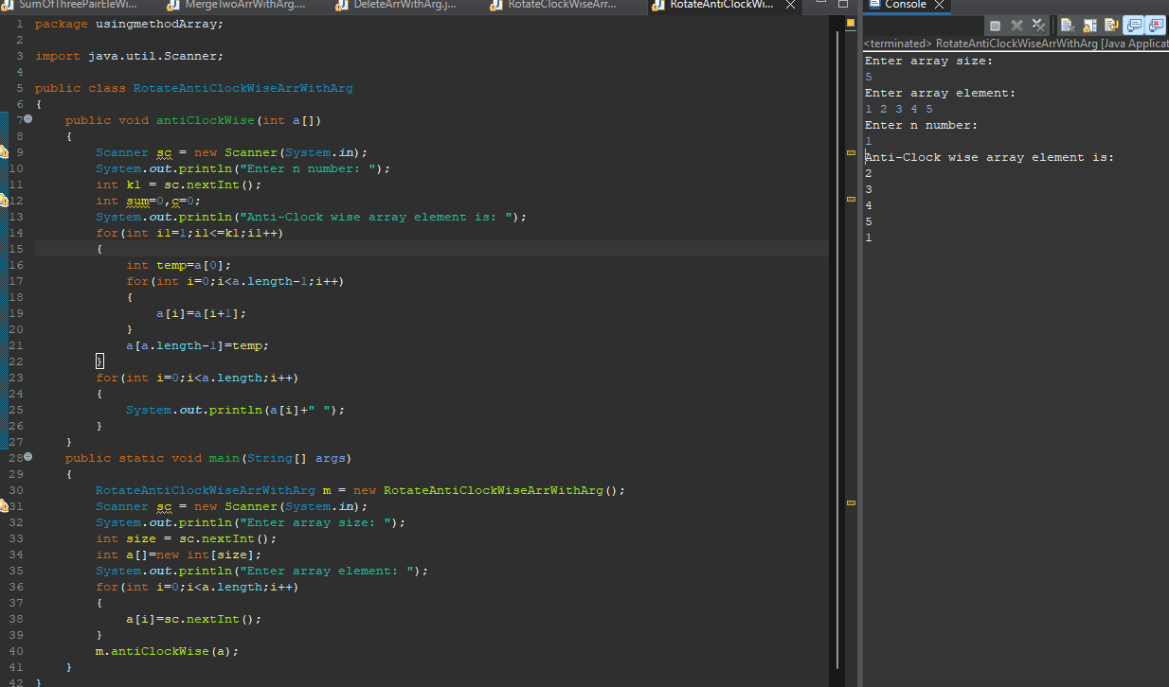

**Q6. Write a program to input an array and rotate it in clock wise by any no given by user.**

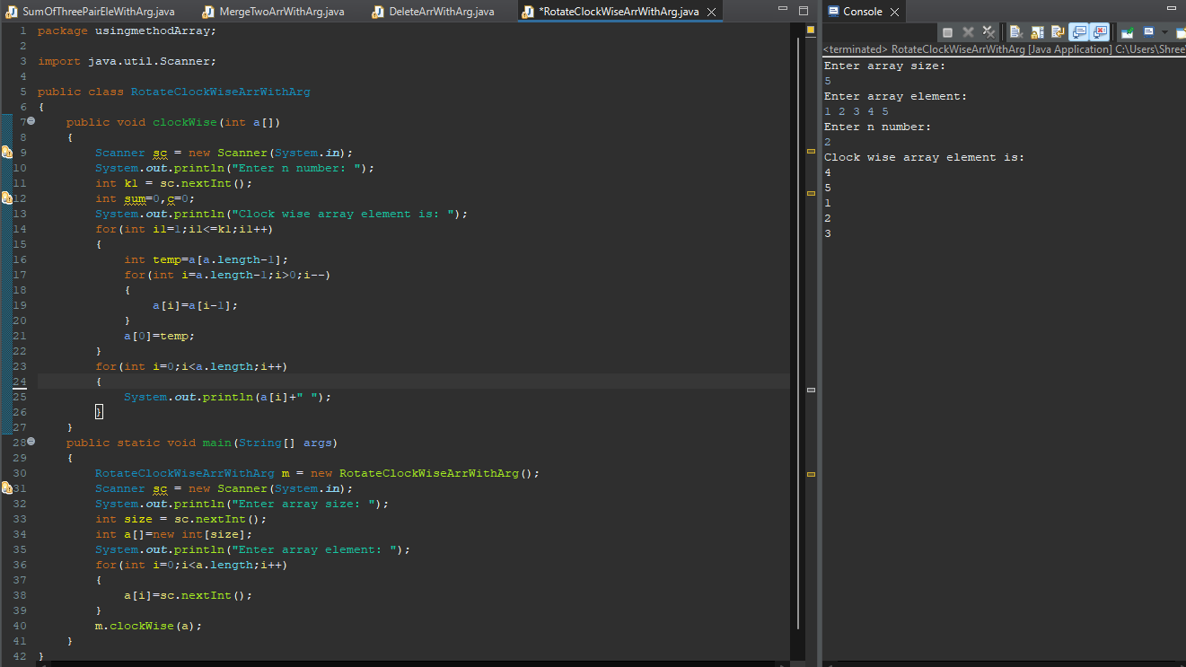

**Q7. Write a program to input an array and delete all duplicate element from array.**

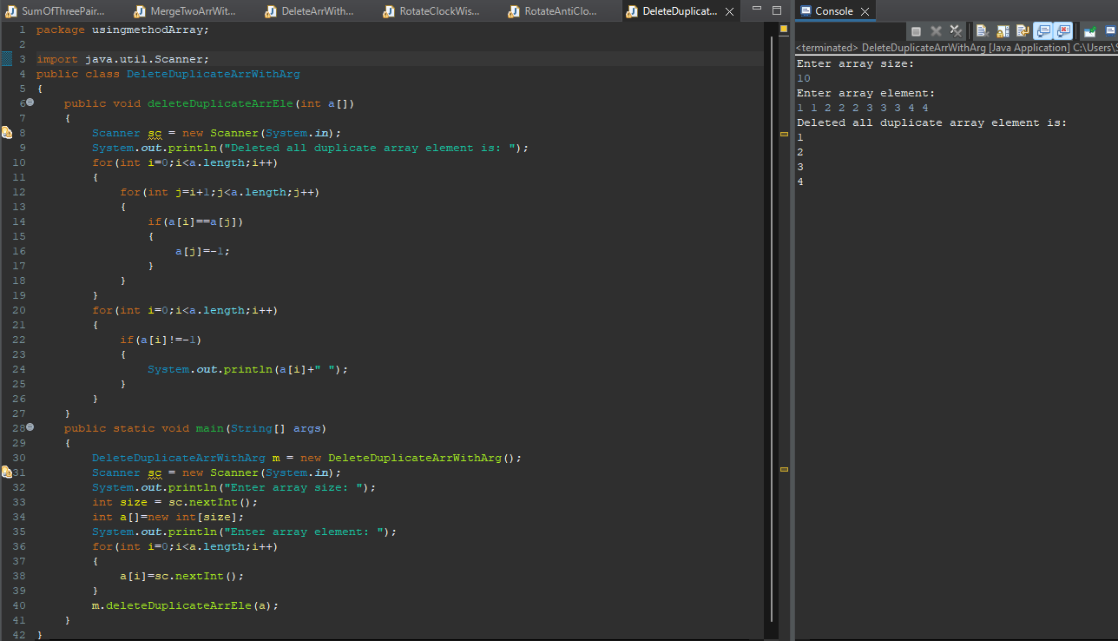

**Q8. Write a Java program to find max number in an array.**

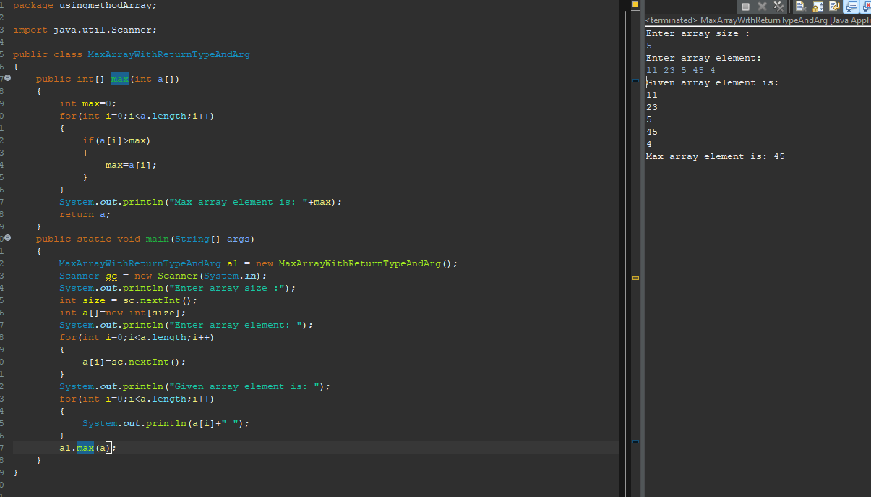

**Q9. Write a program to input an array now insert any element at any position, element and position is taken by user.**

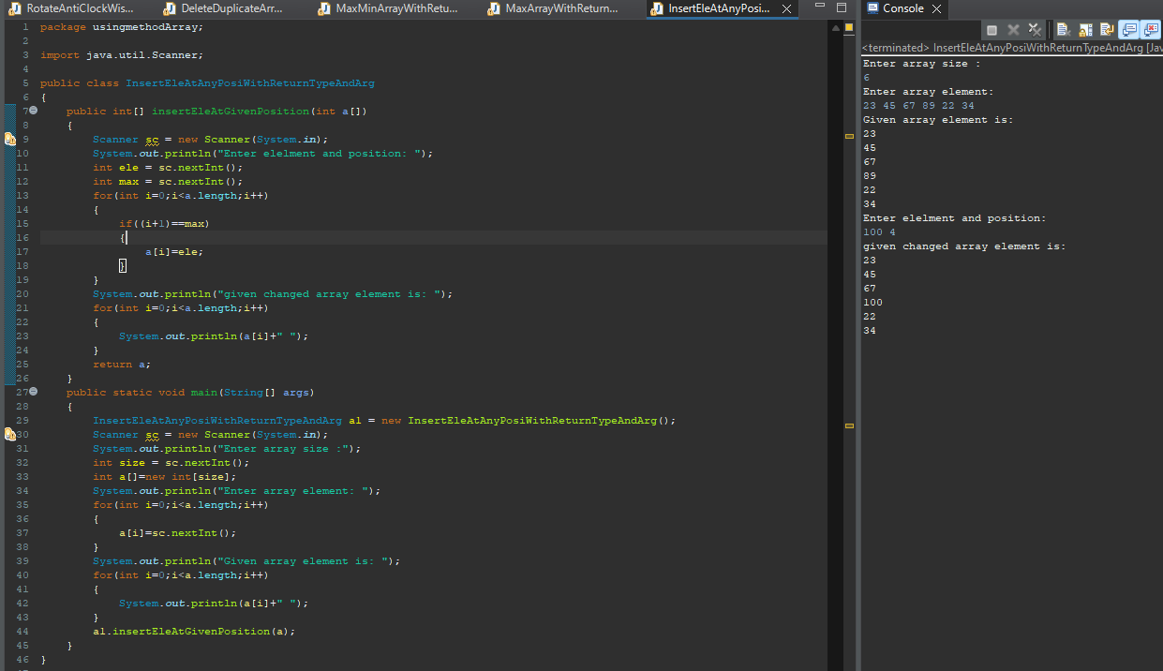

**Q1.Given an array of N integers. Find the first element that occurs at least K number of times.Example 1:Input :N = 7, K = 2, A[] = {1, 7, 4, 3, 4, 8, 7}Output :7**

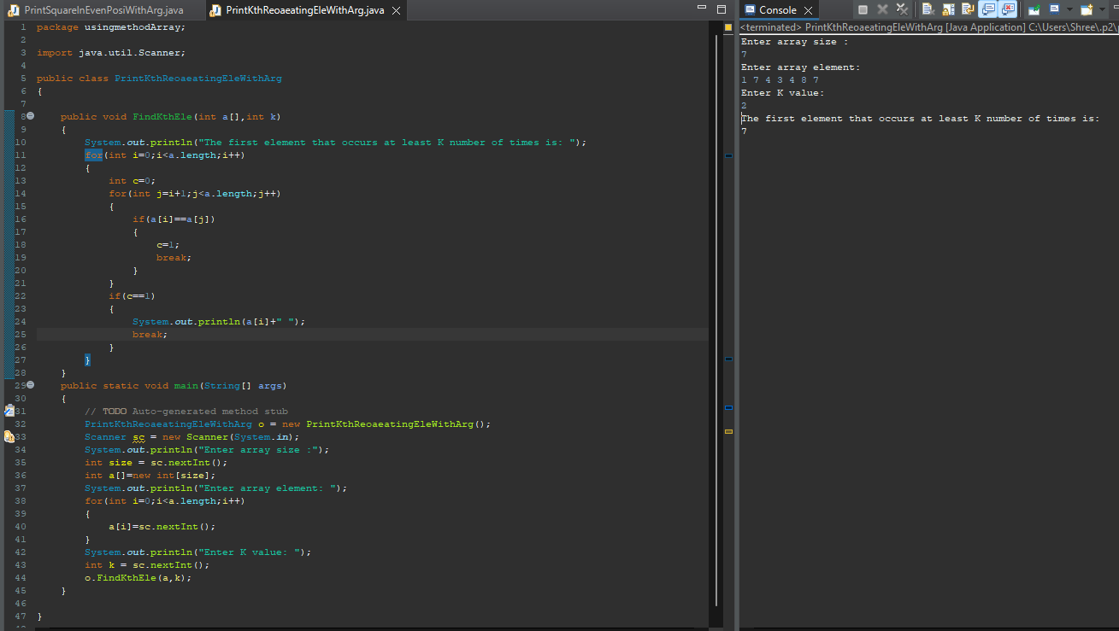

**Q2.Given an array A of positive integers. Your task is to find the leaders in the array. An element of array is leader if it is greater than or equal to all the elements to its right side. The rightmost element is always a leader. Example 1: Input: n = 6A[] = {16,17,4,3,5,2} Output: 17 5 2**

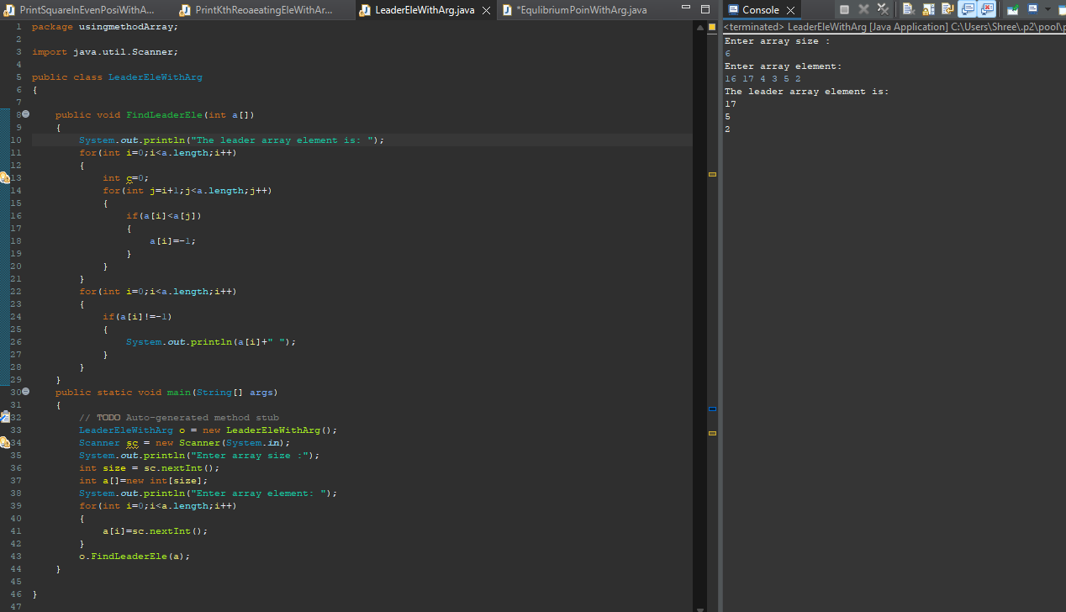

**Q3.Given an array A of n positive numbers. The task is to find the first Equilibrium Point in an array. Equilibrium Point in an array is a position such that the sum of elements before it is equal to the sum of elements after it. Note: Retun the index of Equilibrium point. (1-based index)Example 1:Input: n = 5**

**A[] = {1,3,5,2,2} Output: 3**

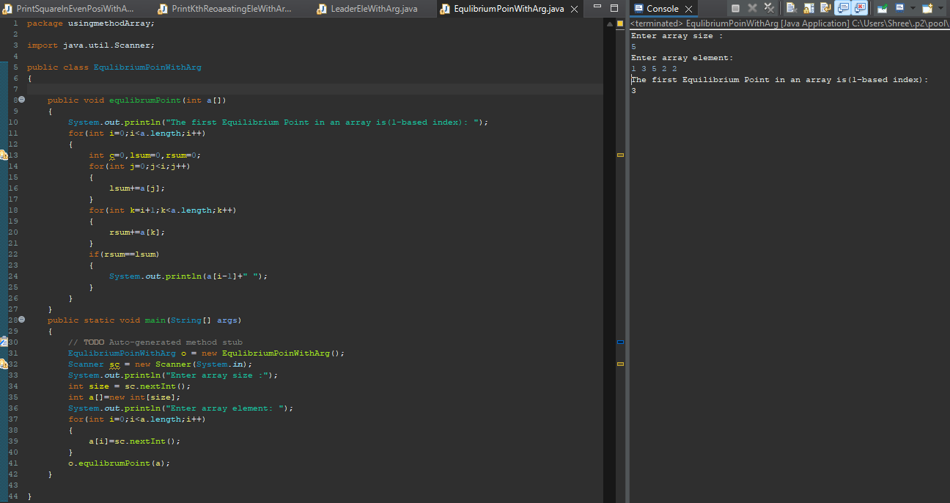

**Q4.You are given two arrays, A and B, of equal size N. The task is to find the minimum value of A[0] * B[0] + A[1] * B[1] + .... + A[N-1] * B[N-1], where shuffling of elements of arrays A and B is allowed.**

**Example 1:**

**Input: N = 3 A[] = {3, 1, 1}**

**B[] = {6, 5, 4}**

**Output:23**

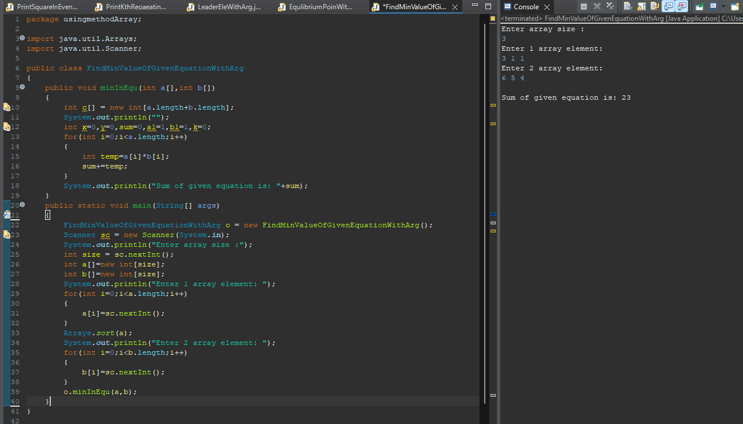

**Q5.Given two sorted arrays arr1 and arr2 of size N and M respectively and an element K. The task is to find the element that would be at the k’th position of the final sorted array.**

**Example 1:**

**Input: arr1[] = {2, 3, 6, 7, 9}, arr2[] = {1, 4, 8, 10}, k = 5, Output:6**

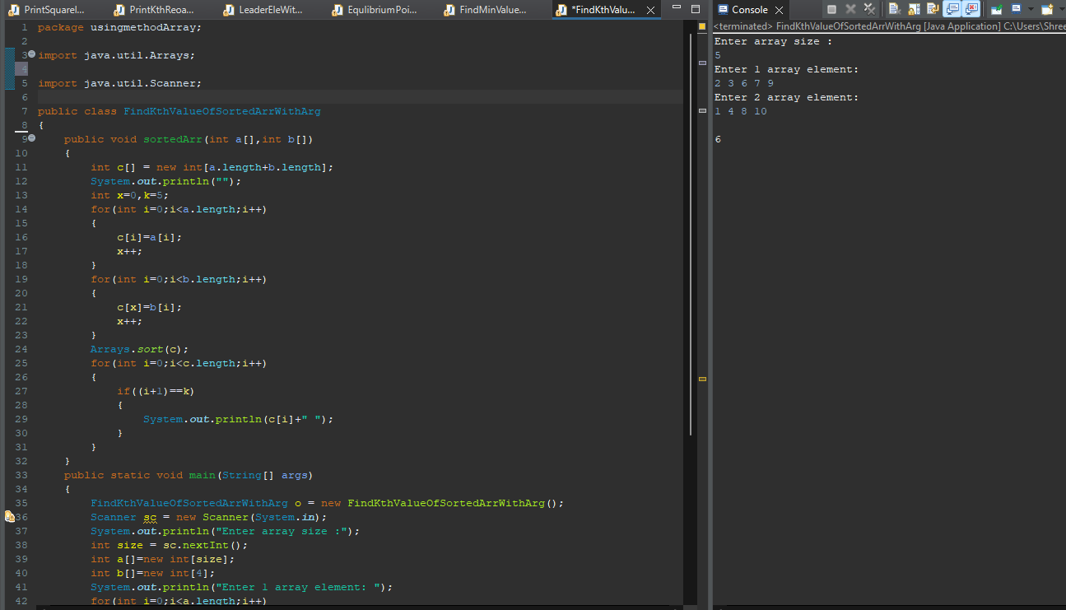 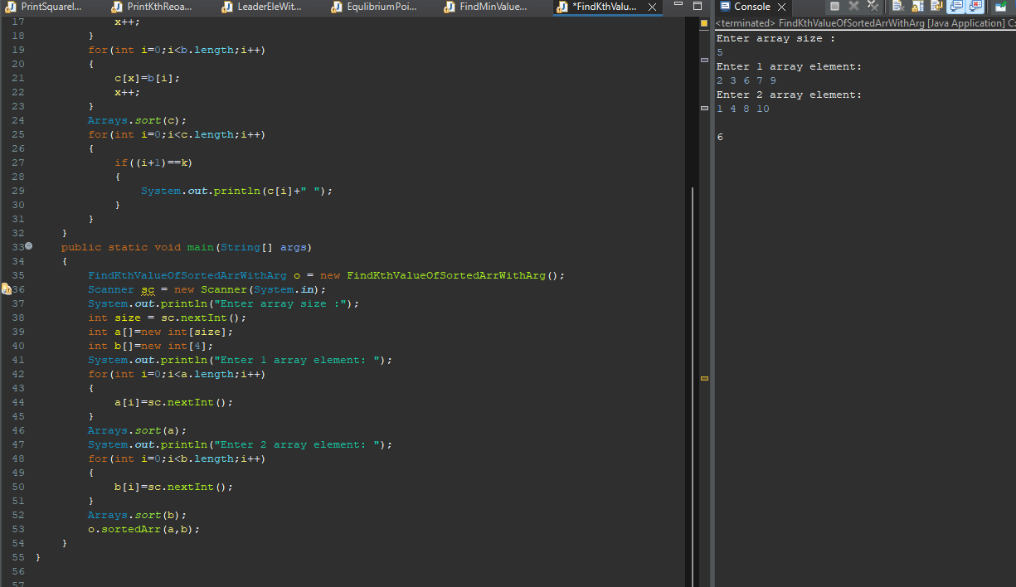

**Q6.Given an array of size N filled with numbers from 1 to N-1 in random order. The array has only one repetitive element. The task is to find the repetitive element.**

**Examples:**

**Input: a[] = {1, 3, 2, 3, 4}**

**Output: 3**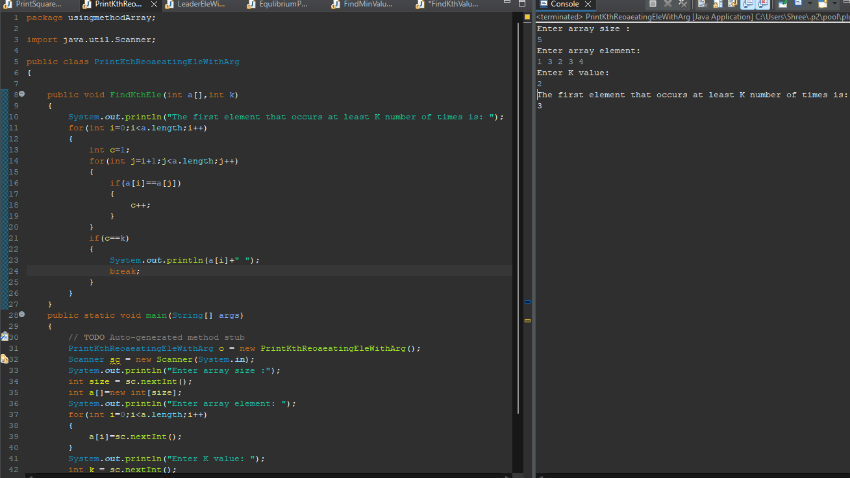 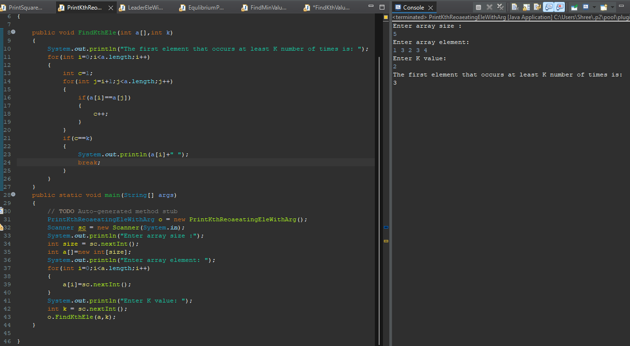

**Q7.Given two unsorted arrays that represent two sets (elements in every array are distinct), find the union and intersection of two arrays.**

**Example: arr1[] = {7, 1, 5, 2, 3, 6} ,arr2[] = {3, 8, 6, 20, 7}**

**Then your program should print Union as {1, 2, 3, 5, 6, 7, 8, 20} and Intersection as {3, 6, 7}. Note that the elements of union and intersection can be printed in any order.**

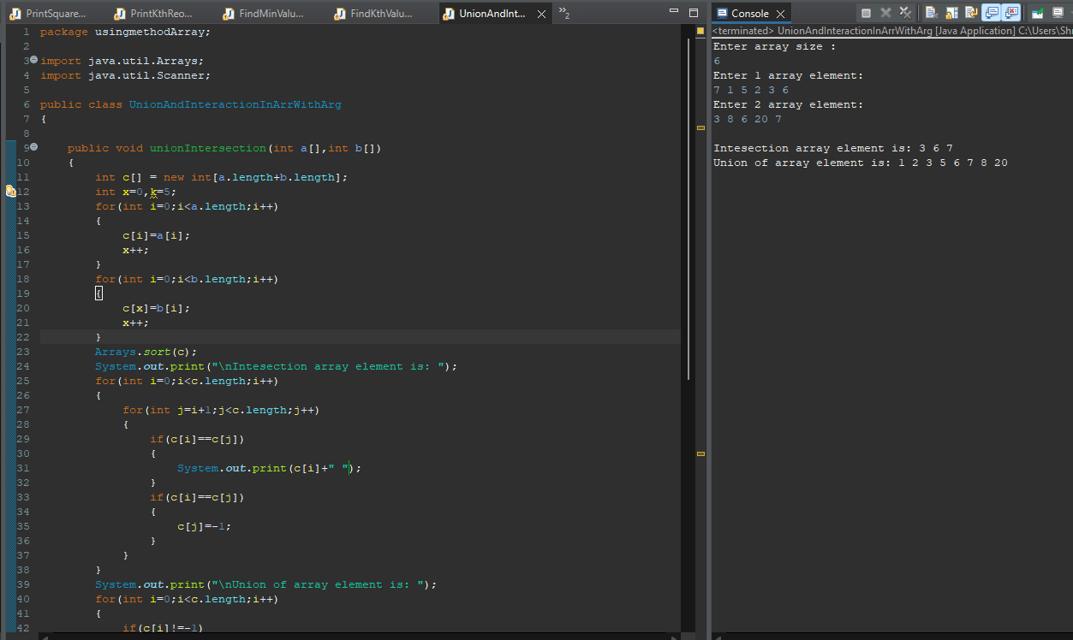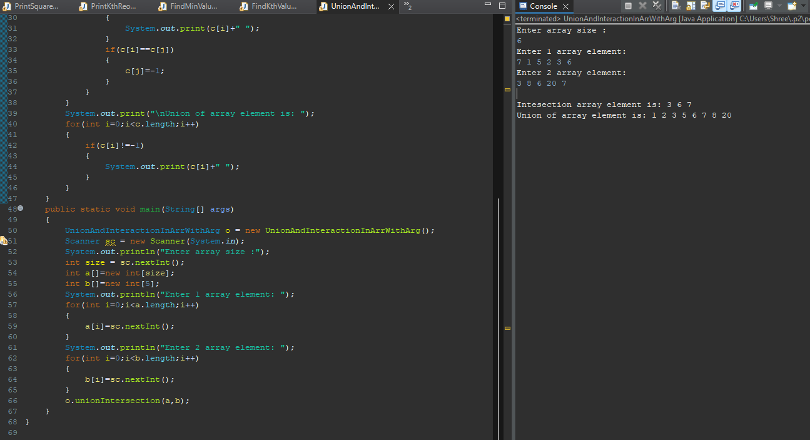

**Q8.Given three arrays sorted in non-decreasing order, print all common elements in these arrays.**

**Examples: Input: ar1[] = {1, 5, 10, 20, 40, 80} ,ar2[] = {6, 7, 20, 80, 100} ,ar3[] = {3, 4, 15, 20, 30, 70, 80, 120} ,Output: 20, 80**

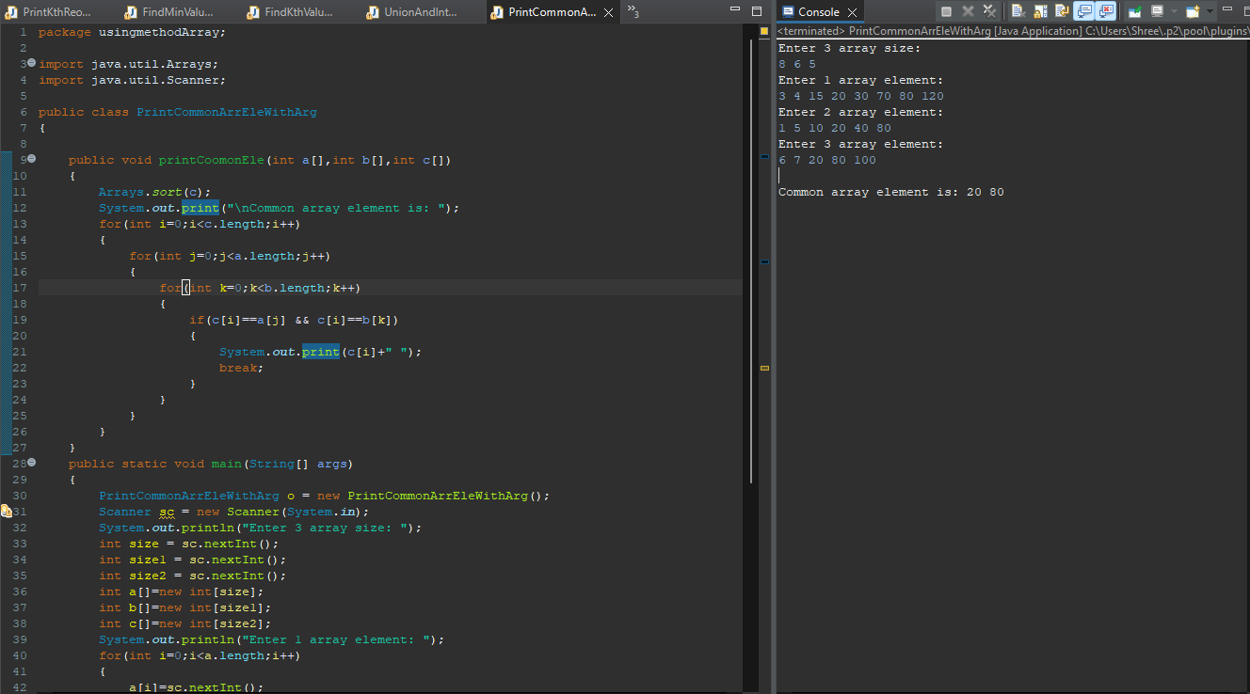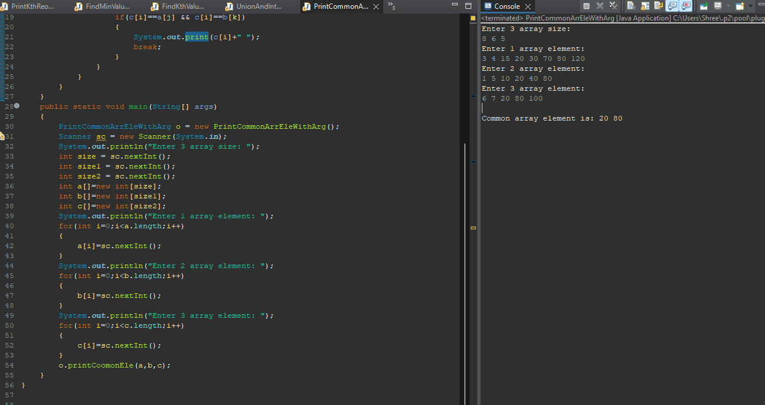

**Q10.Given an array arr[] of integers, segregate even and odd numbers in the array. Such that all the even numbers should be present first, and then the odd numbers.**

**Examples:**

**Input: arr[] = 1 9 5 3 2 6 7 11**

**Output: 2 6 5 3 1 9 7 11**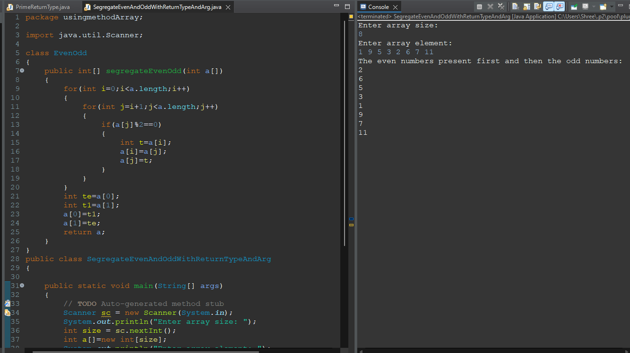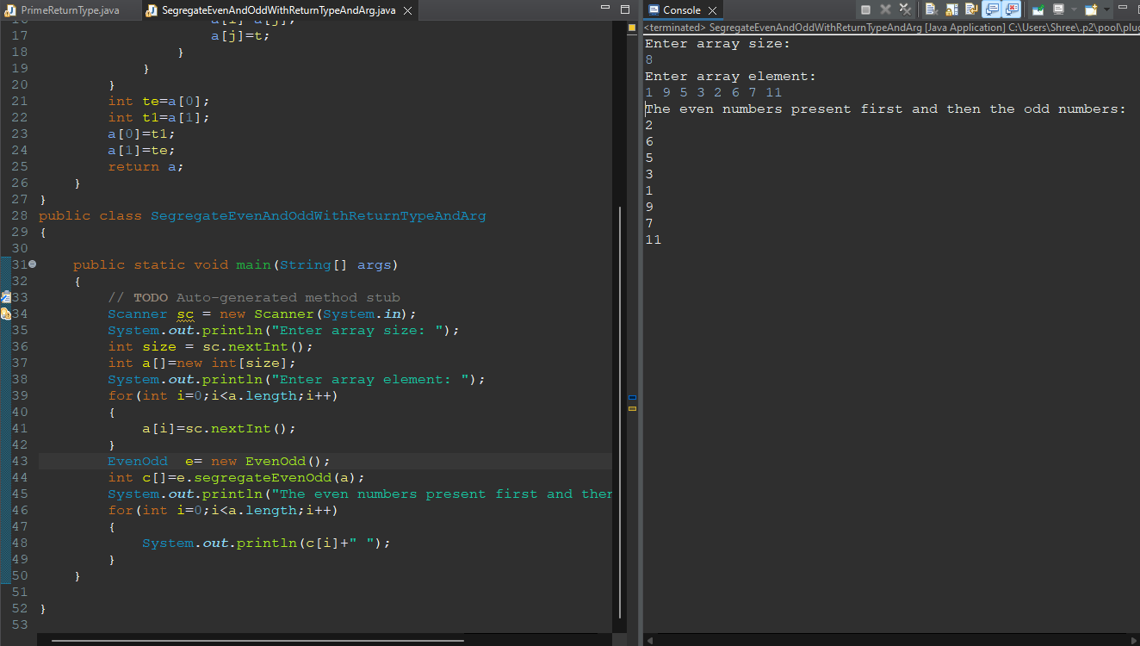

**Q11.Given a sorted array of n distinct integers where each integer is in the range from 0 to m-1 and m > n. Find the smallest number that is missing from the array.**

**Examples:**

**Input: {0, 1, 2, 6, 9}, n = 5, m = 10**

**Output: 3**

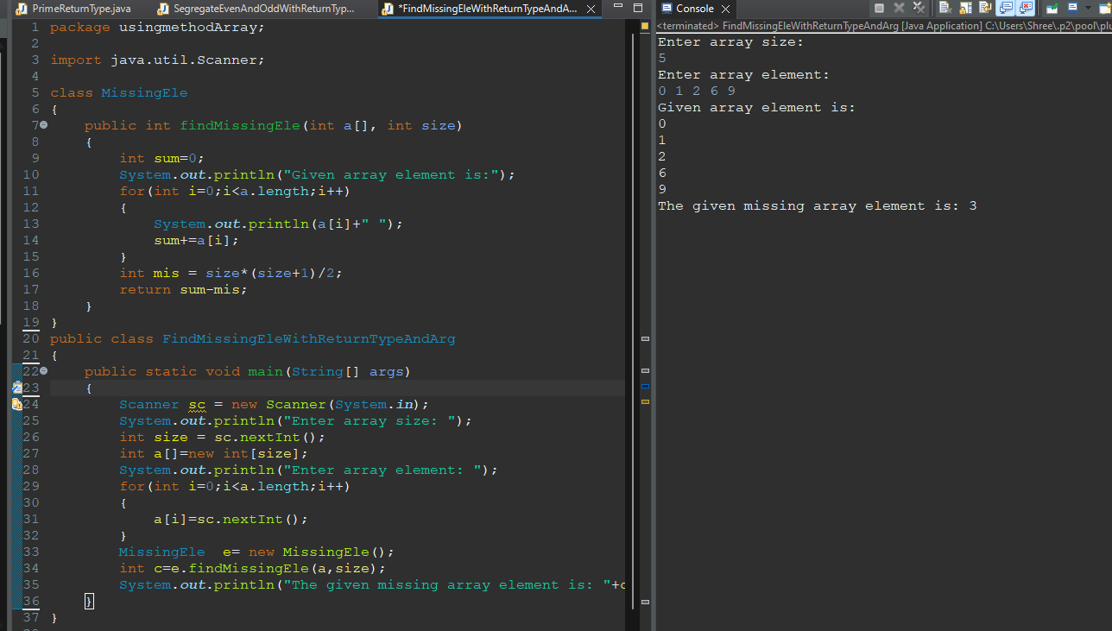

**Q12.Given a sorted array with possibly duplicate elements. The task is to find indexes of first and last occurrences of an element X in the given array.**

**Note: If the element is not present in the array return {-1,-1} as pair.**

**Example 1:**

**Input:N = 9**

**v[] = {1, 3, 5, 5, 5, 5, 67, 123, 125}**

**X = 5**

**Output:2 5**

**Explanation:**

**Index of first occurrence of 5 is 2**

**and index of last occurrence of 5 is 5.**

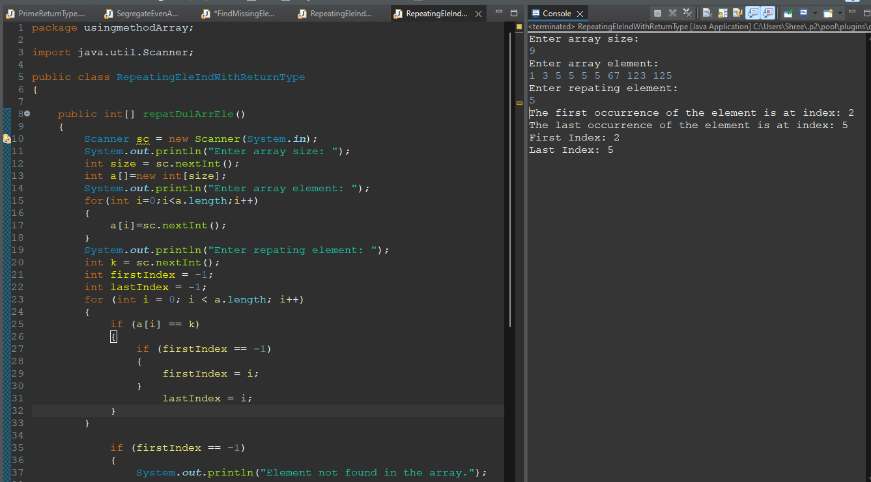 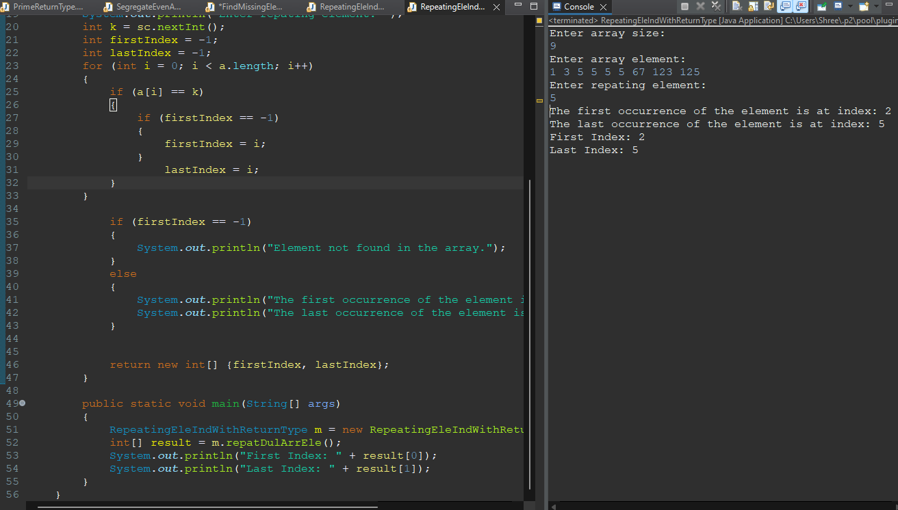

**1. Write a Java program to find maximum product of two integers in a given array of integers.**

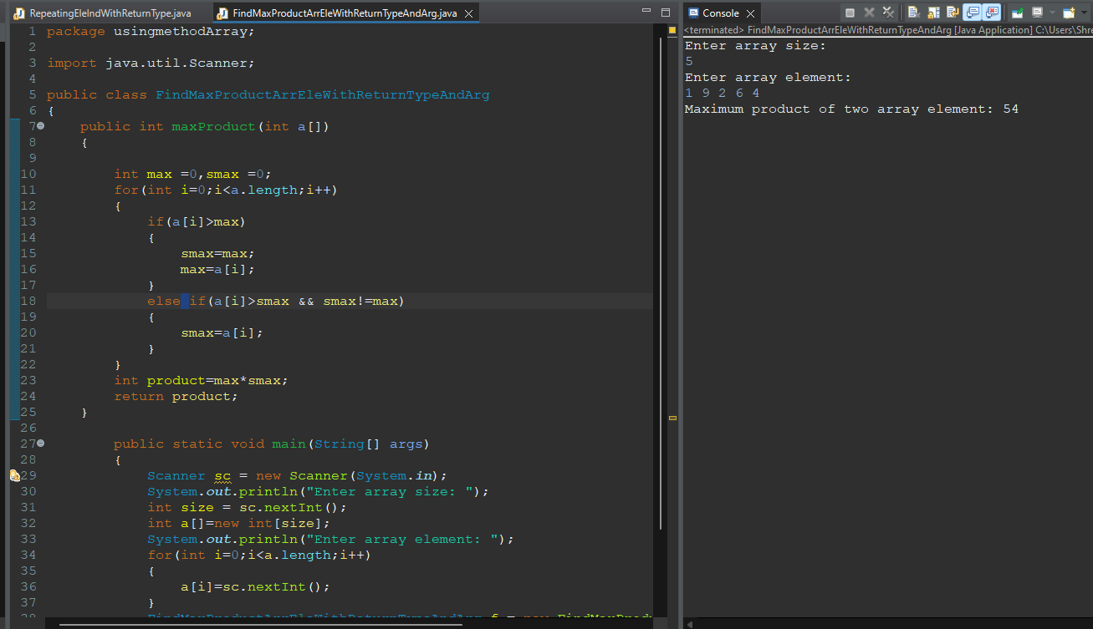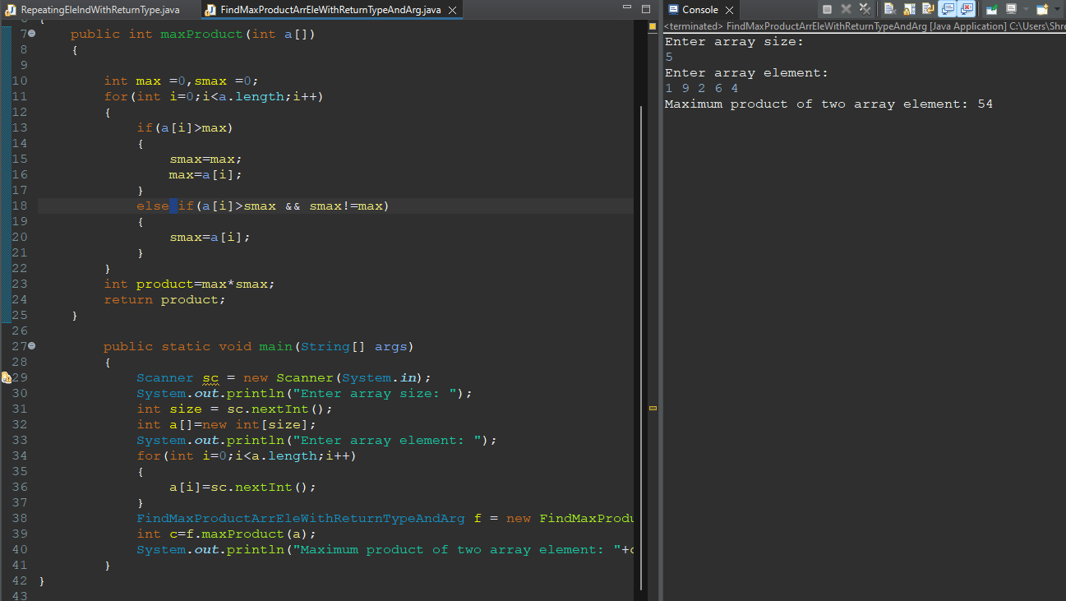

**2. Write a Java program to shuffle a given array of integers.**

**Example:**

**Input: nums = { 1, 2, 3, 4, 5, 6 }**

**Output: Shuffle Array: [4, 2, 6, 5, 1, 3]**

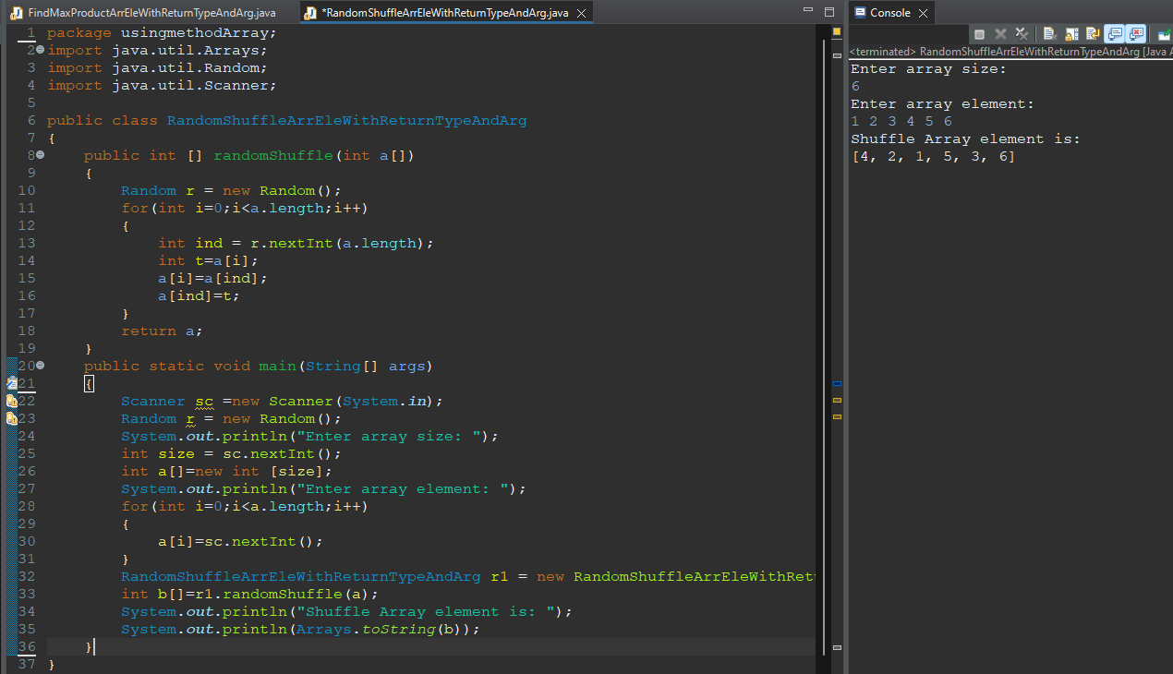

**3. Write a Java program to rearrange a given array of unique elements such that every second element of the array is greater than its left and right elements.**

**Example:**

**Input :**

**nums= { 1, 2, 4, 9, 5, 3, 8, 7, 10, 12, 14 }**

**Output:**

**Array with every second element is greater than its left and right elements:**

**[1, 4, 2, 9, 3, 8, 5, 10, 7, 14, 12]**

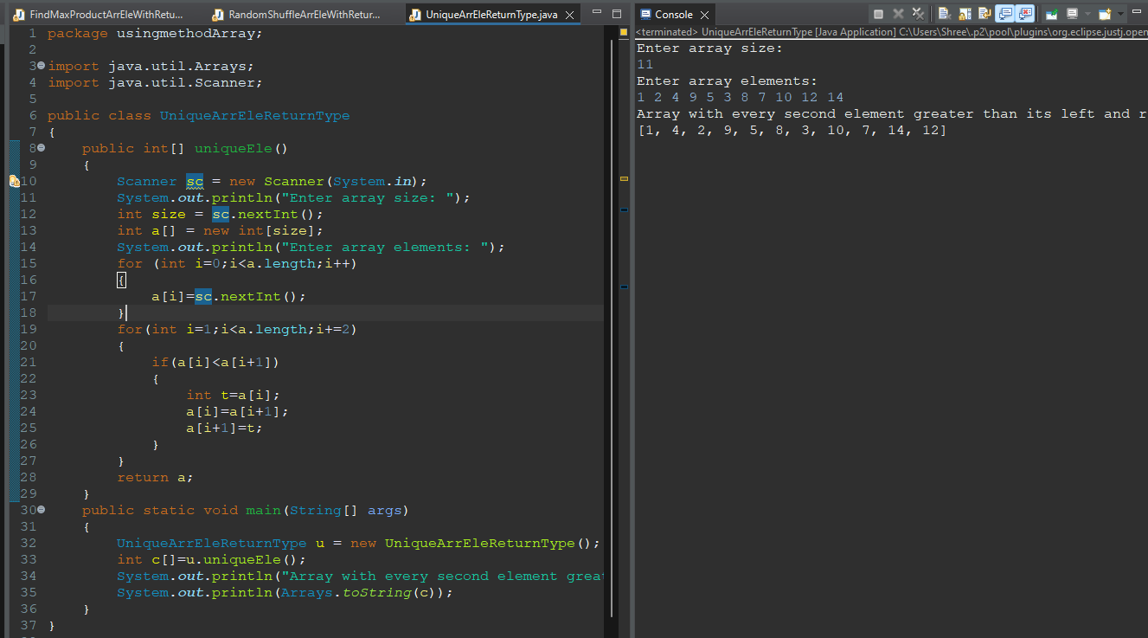

**4.Write a Java program to replace each element of the array with product of every other element in a given array of integers.**

**Example:**

**Input :nums1 = { 1, 2, 3, 4, 5, 6, 7},nums2 = {0, 1, 2, 3, 4, 5, 6, 7}**

**Output:**

**Array with product of every other element:**

**[5040, 2520, 1680, 1260, 1008, 840, 720]**

**Array with product of every other element:**

**[5040, 0, 0, 0, 0, 0, 0, 0]**

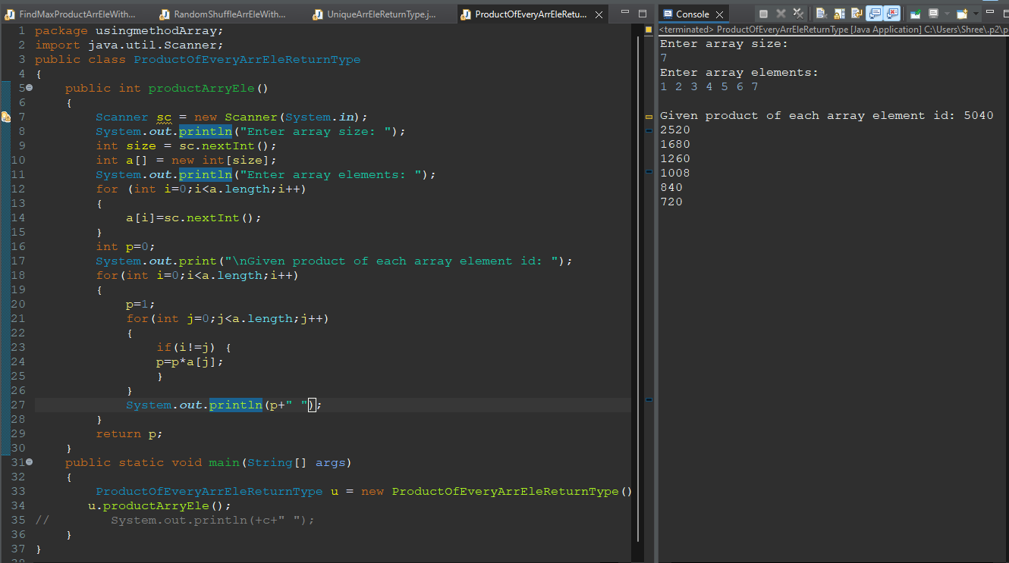

**5. Write a Java program to find maximum difference between two elements in a given array of integers such that smaller element appears before larger element.**

**Example:**

**Input :nums = { 2, 3, 1, 7, 9, 5, 11, 3, 5 }**

**Output:The maximum difference between two elements of the said array elements:10**

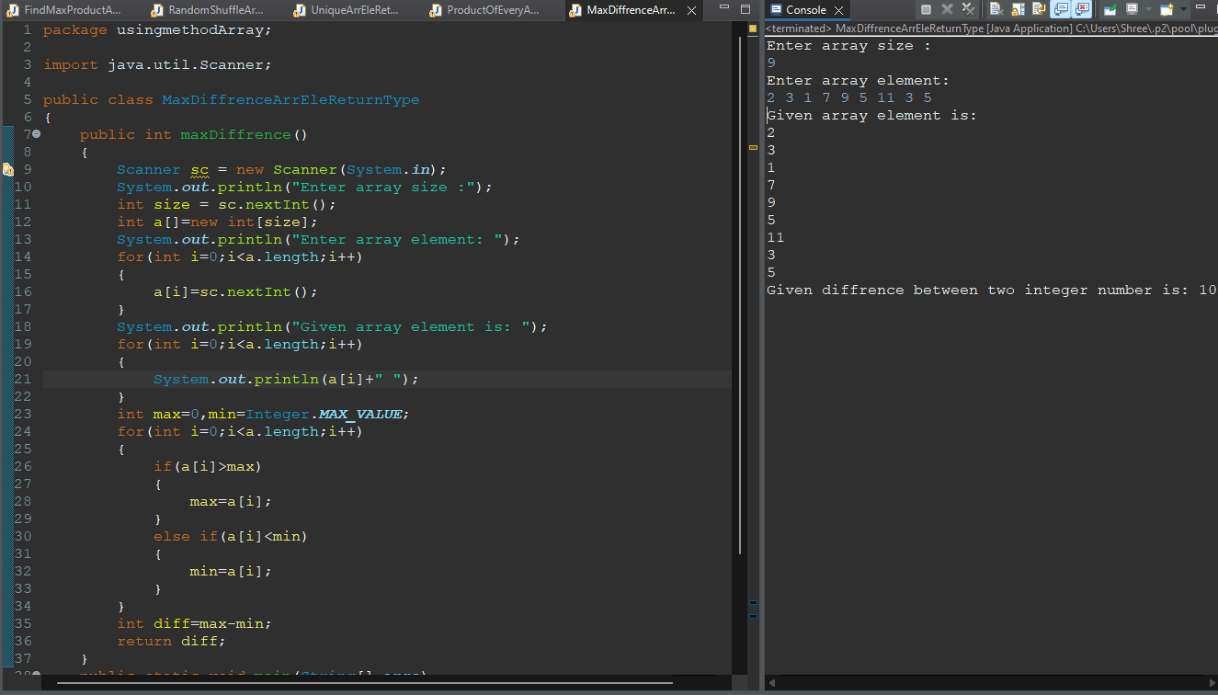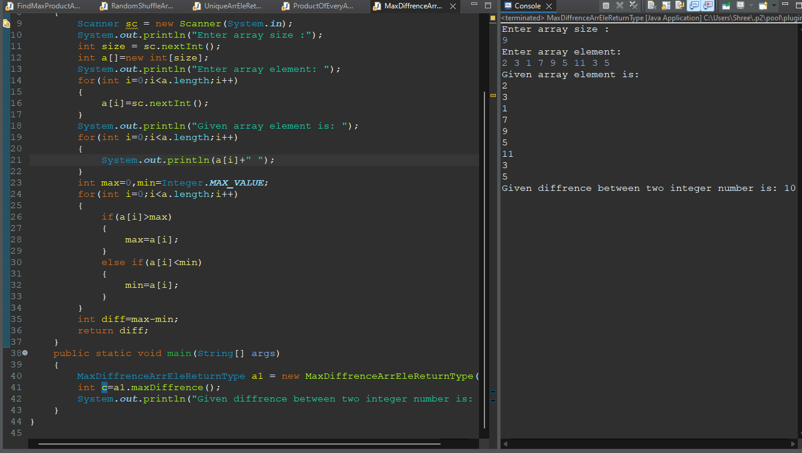

**6. Find a peak element which is not smaller than its neighbors**

**Input: array[]= {5, 10, 20, 15}**

**Output: 20**

**Explanation: The element 20 has neighbors 10 and 15, both of them are less than 20.**

**Input: array[] = {10, 20, 15, 2, 23, 90, 67}**

**Output: 20 or 90**

**Explanation: The element 20 has neighbors 10 and 15, both of them are less than 20, similarly 90 has neighbors 23 and 67.**

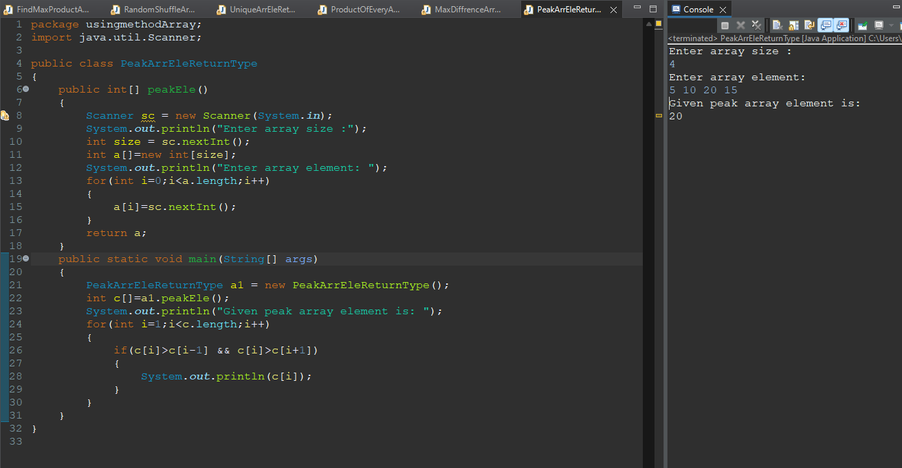

**Q11.Given an unsorted array arr[] with both positive and negative elements, the task is to find the smallest positive number missing from the array.**

**Note: You can modify the original array.**

**Examples:**

**Input: arr[] = {2, 3, 7, 6, 8, -1, -10, 15}**

**Output: 1**

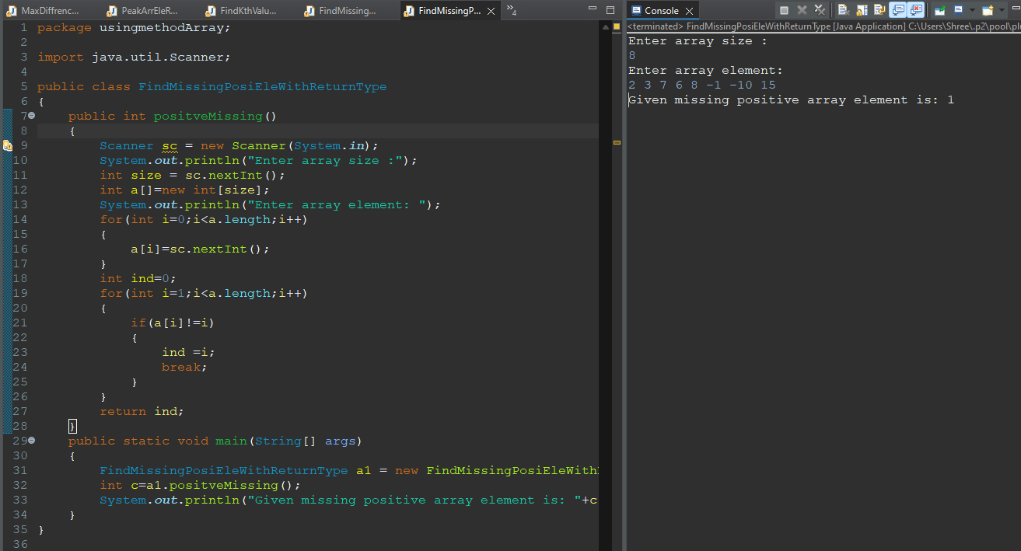

**Q12.Find the majority element in the array. A majority element in an array A[] of size n is an element that appears more than n/2 times (and hence there is at most one such element).**

**Examples :**

**Input : {3, 3, 4, 2, 4, 4, 2, 4, 4}**

**Output : 4**

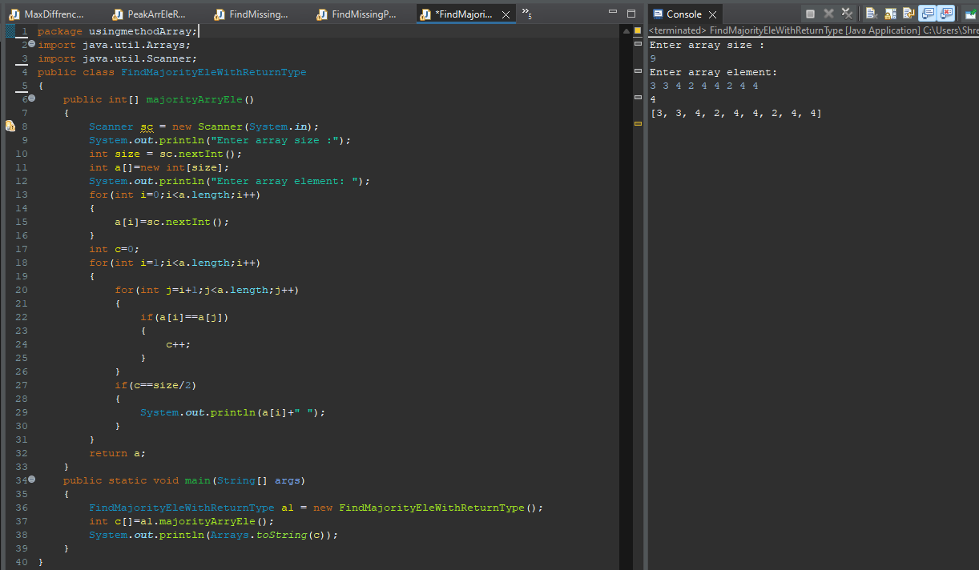

**Q13. Given two sorted arrays A and B of size p and q, write a Java program to merge elements of A with B by maintaining the sorted order i.e.**

**fill A with first p smallest elements and fill B with remaining elements.**

**Example:Input :int[] A = { 1, 5, 6, 7, 8, 10 }int[] B = { 2, 4, 9 } Output:Sorted Arrays:A: [1, 2, 4, 5, 6, 7] B: [8, 9, 10]**